Actor’s Decade-Long Battle With His Receding Hairline


Released on: May 4, 2009, 3:03 am
Author: The Hospital Group
Industry: Healthcare
Television heartthrob James Nesbitt has sparked rumours he has plumped for hair transplantation treatment, as photographs taken this week show the Irish lothario sporting a much fuller hairline.
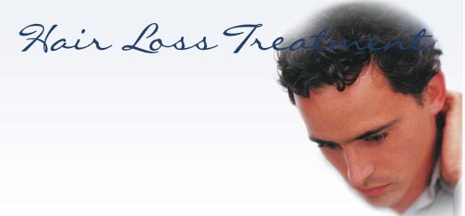
The 44-year-old star of the Yellow Pages adverts has made no secret of his fears of going bald, and has admitted to succumbing to every treatment the services directory could throw at him.
In 2001 he confessed to taking vitamin tablets to slow his hair loss, and four years ago resorted to a stimulating lotion to boost growth. Speaking about the lotion at the time, Nesbitt said: “It made me feel like my scalp was going to explode. It said it opened the pores of the scalp to encourage new growth. It’s ridiculous, but it’s horrible going bald.”
The former Cold Feet actor has admitted he worried his thinning hairline would affect his career, and men in the United Kingdom with similar concerns can find a solution thanks to The Hospital Group. The Hospital Group, the UK’s leading cosmetic surgeons, perform more hair restoration procedures than any other surgery provider, and only carry out natural hair transplants using the latest Follicular Hair Transplantation techniques.
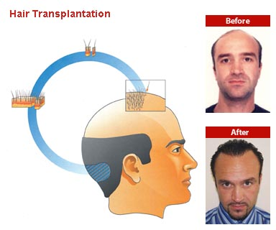
Follicular Transplantation involves transplanting hair units, often with four or five hairs growing from one follicle, to a bald spot to generate growth.
Human hairs are genetically programmed to either be sensitive to the male hormone, which causing them to die, or to be permanently immune to the hormone and last a lifetime. Hair Transplantation uses the ‘lifetime growth’ hairs from around the back of the head, and transplants them in areas where the hairs have died.
Hair Transplantation at The Hospital Group is a minor surgical procedure, taking little more than three hours. The Hospital Group’s hair restoration and transplantation clinic was founded in 1992, and is staffed with industry experts at its dedicated Dolan Park Hospital in the Midlands.
The Hospital Group is committed to providing the very highest standards and all procedures are performed by an expert medical team in state-of-the-art facilities that are second to none. Since The Hospital Group was established, it has grown from a small pharmaceutical company to one of the UK’s foremost cosmetic surgery providers.
Contact Details: For further information of The Hospital Group’s range of hair restoration procedures, surgery-seekers should visit the website thehospitalgroup.org or call our patient care coordinators on 0845 762 6727.

