Anabolic Steroids For Sale Found Safely On Steroid Sources
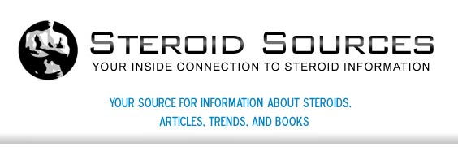

Released on: May 14, 2009, 6:22 am
Author: steroidsources.com
Industry: Healthcare
May, 2009: Buying steroids does not have to be difficult. In fact, the long process of deciding which steroids to use, if you truly want to use them, researching how to properly use them and finding the proper place online to purchase them online should be the difficult part. Leave it to the steroid sales professionals at Steroid Sources to provide the safest and legal steroids for purchase!

Why trust Steroid Sources? With several years of experience and countless successful sales, the website is a number one retailer of anabolic steroids for sale. Buying steroids with SS is easy! Whether someone looking for medicinal help or for those looking for increased performance in sports (whether professional athlete or not), the safety involved with using steroids is the same. When buying steroids online, it's important to read all descriptions of the product and health risks and usage and frequency information. If this information isn't followed closely, great health risks occur.
Because of the many reactions that can occur with the use of steroids, a health care professional should always be consulted before using steroids. While Steroid Sources is a great source of information, they are not health care professionals nor certified or licensed to provide health information. They simply tell you general information and give you suggestions of what to do before purchasing and how to use them after buying steroids.
Some important information that should be provided before buying steroids includes:
The law regarding the purchase of steroids for those 18 and over ONLY. The potential for abuse and how to protect one's self from becoming addicted to steroids. Information on various laws that exist when purchasing steroids, whether anabolic steroids) or not, online.
When looking for anabolic steroids for sale, Steroid Sources has several options to choose from. With comprehensive information and descriptions throughout the website, SS guides you through the decision-making process of choosing which steroids to buy.
Steroid Sources is one of the number one trusted websites to find anabolic steroids for sale. What makes them different is their dedication to informing their customers on the risks involved with steroid use. Steroid Sources provides a 100% guarantee to all customers looking to buy steroids from them. What are you waiting for? Try Steroid Sources today!
For more information on Steroid Sources and buying steroids, visit their official website at Steroidssources.com. Their anabolic steroids for sale and steroids online pages will both give you helpful information on how to safely purchase steroids online and other FAQ's. Visit Steroid Sources today for trusted steroid options on the web!
Contact Details: http://steroidsources.com/
SS, Inc.
22nd Avenue
P. O. Box 530007
St. Petersburg, FL 33747

