Ataccama releases Data Quality Center version 5
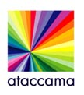

Released on: May 26, 2009, 7:59 am
Author: Ataccama Software
Industry: Software
Prague, 26 May 2009 – Ataccama Corporation, an international software company developing next generation technologies for managing data quality and Master Data Management, announces the immediate release of a new version of Ataccama Data Quality Center 5 (DQC). Ataccama DQC is a tool for complex management of data quality, used by banks, insurance companies and government agencies in the Czech Republic and other countries in Europe and North America.
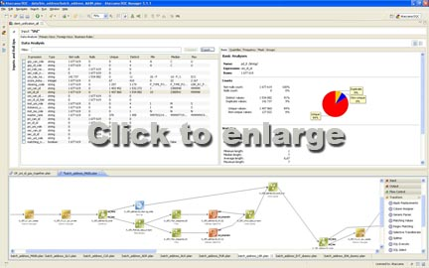
“Version 5 brings a large number of new features and improvements,” says Michal Klaus, CEO of Ataccama. “Among the most important are improved usability of the application, specifically for new users, improved features for data analysis and parallel unification.”
The new version brings a significantly improved user experience, making the tool more efficient. The updated version now includes interactive validation of code and configurations, testing of expressions, regular expressions and patterns. Beginner users will appreciate the number of commented samples together with video demonstration tutorials.
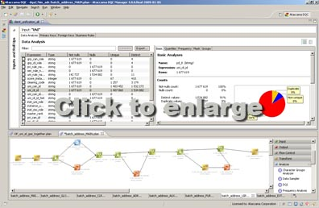
During initial data analysis (profiling), users can now leverage more advanced functions, such as frequency analysis of masks, histograms of group counts, the ability to drill down to details of data records and export of outputs to XML and HTML. The optimized core of DQC allows achieving processing speeds in the range of a million records per minute during profiling.
Parallel unification allows simultaneous processing of batch data together with concurrent online requests. To allow continuity of service, it is important to allow changing reference databases while the server is running. “This is a crucial requirement “, adds Klaus, “the tool is deployed as part of key processes in large enterprises and thus has to guarantee high availability and reliability “.
Ataccama Software, with its registered office in Prague, is a part of the international software company Ataccama Corporation, which develops top technologies specialized in data quality management and Master Data Management. Major financial institutions, telecommunication companies, power plants, and public administration authorities choose Ataccama technologies due to their customer-friendliness and real contribution to their businesses. Ataccama Software customers include GE Money Bank, Raiffeisenbank, The Všeobecná úverová banka bank, T-Mobile SK and the Ministry of Transport of the Czech Republic. More information at www.ataccama.com.
Should you require more information please contact:
Ian Formanek
Chief Marketing Officer
Ataccama Software
Tel. +420 602 142 566
jan.formanek@ataccama.com

