Australian Icon Gets A Facelift
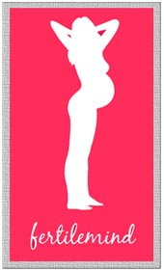

Released on: May 19, 2009, 7:28 am
Author: Fertile Mind Pty Ltd
Industry: Apparel & Fashion
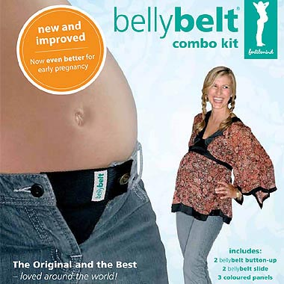
An icon for pregnant women, Belly Belt has undergone a facelift. The kit that turns normal clothes into maternity wear has been tweaked to be even better for early pregnancy.
Inventor and founder Christine Kininmonth says the change is only the second in 10 years.
“We listed to feedback from our customers and heard that women wanted to wear Belly Belt earlier in their pregnancy,” she said. “The changes we’ve made in our maternity kit mean you can now wear your trousers, skirts and short the moment you can no longer button up your fly.”
Belly Belt is an Aussie success story. The maternity kit is now sold throughout the world.
“We have a lot of enthusiasm for Belly Belt in many places, but Burma is probably the most exotic,” Christine says. “If I think back to the early days, I would never had imagined we’d be selling my little Australian invention in Burma!.”
The success of Belly Belt led 10 years ago to the formation of the company Fertile Mind. Christine and her business partner Peter Hooker now employ six staff and have a warehouse filled with maternity dresses, maternity jeans, breastfeeding tops, nursing pillows and maternity accessories.
“We’ve diversified into a range of maternity wear and nursing wear,” says Christine, “so we’re probably one of the growing players in the Australian maternity industry.” Fertile Mind is a family-friendly workplace, so most of the women selling maternity wear are mums themselves.
‘It’s important for us to sell only maternity wear and breastfeeding clothing that we would have bought for our own pregnancies,” emphasises Christine. “We’re mums a few times over so we’re pretty picky.”
While Belly Belt is one of the more successful of their maternity accessories, it’s getting a run for its money by the Milkbar Portable Nursing Pillow.
Christine enthuses, “This pillow has just taken off. We are sending out mountains of these to our maternity store and baby store stockists, they are selling so well.”
The Milkbar Portable Nursing Pillow was invented by a Sydney mother to ease back and shoulder strain when breastfeeding a baby.
“It’s wonderful to see inventions such as Belly Belt and The Milkbar gain a following, as it’s a credit to mother-inventors,” says Christine.
Maternity stores and baby stores will be receiving the new Belly Belt kit from today. Christine hopes it will make the Belly Belt more popular that ever. “Pregnant women in Australia have been very supportive. They may be cautious spending as much on maternity wear in a recession, so Belly Belt has its place in a flat market.”
Belly Belt maternity kit sells for $29.95 and can be found at www.fertilemind.com.au
Contact Details: Fertile Mind Pty Ltd
PO Box 215, Seaforth NSW 2092
Phone: +61 2 9905 0199
Fax: +61 2 9905 0322
sales@fertilemind.com.au
www.fertilemind.com.au

