Base London Introduce New Larger Sizes Collection
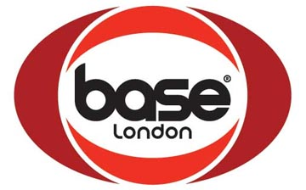
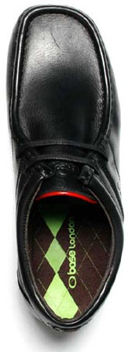
Released on: May 14, 2009, 5:31 am
Author: Base London
Industry: Retail
Base London, men's footwear brand, has always been a big name in men's shoes, but now it is big in big shoes too. Producing a range of larger size men's leather formal and casual shoes, Base London is set to give the more ample sized guy a choice of fashion shoes that he can finally be proud to wear, with a choice of formal and casual styles ranging from size UK 12 to 15 (EUR 46 to 50).
Base London has released the men's casual leather styles Vital Excel, Vista Excel and Control Excel in new mens large size shoes. These are all men's fashion shoes crafted from the finest leathers, and are ideal for men who don't want to sacrifice style just because they need big size shoes and want to have a relaxed look.
Control Excel by Base London brings a classic casual men's lace up wallaby shoe, up to date with fresh detailing. Whether for a few drinks with friends or for a more dressed down look at work, this luxury leather versatile style is a great choice to complement any look.
Vital Excel and Vista Excel both incorporate rich crazy leathers with modern, up to date detailing to freshen up classic moccasin constructed casual loafers. A dual centre seam stitch runs down a vamp that is encircled by a chunky stitch that brings design features and stylish quality to the shoes. Vital Excel features an elasticated gusset to make the slip on extra comfortable, whilst Vista Excel reveals a fashionable side lace system, and both are packed with details and ooze style. Design heavy yet perfectly formed, Vista Excel and Vital Excel are ideal for any situation from catching up with a few mates down the pub or blagging the way into a club.
For the more formal occasion Base London's smart formal men's formal shoe Sense Excel, is the perfect slip on men's loafer, with its strong detailing and high quality leathers. It takes a classic slip on loafer but adds a unique sole which wraps up onto the upper of the shoe at each side to create a contemporary look. This is combined with precise hand stitching around the moccasin toe and a luxurious leather outer and interior. An extremely versatile men's shoe; it will be a staple for work with a suit or teamed with casual clothes for a more relaxed post work drink.
The new additions to the Base London collection mean larger men can step out of the box this summer and into a new more stylish, fashionable pair of Base London formal and casual mens shoes.
About Base London
Base London was founded in 1995 after a niche was spotted in the market - branded fashion formal footwear for the high street shoe shop. Previously consumers had the choice of own label or exclusive designer names with nothing in between.
The Base London Brand was launched at around the same time as lads' mags such as FHM hit the shelves for the first time. These provided the perfect platform to talk directly to the target audience.
Keeping in line with consumer needs, the footwear range was expanded to include more casual styles. Base London rapidly earned an excellent reputation for high quality, affordable mens designer shoes and remains market leader in this arena.
Base London has received public commendation in the form of numerous finalist nominations in the Footwear Brand of the Year category of the FHM/Drapers Footwear Brand Awards. The company has actually gone on to win the award a remarkable 3 times - more than any other fashion brand has achieved.
Base London media contact:
Pete Winkworth
Base London Ltd
4/6 Buckingham Court
Rectory Lane
Loughton
Essex
IG10 2QZ
0208 542 5421
www.baselondon.com

