Collaborate, Communicate, and Socialize – Now the Bitrix Way


Released on: May 14, 2009, 4:51 am
Author: Bitrix, Inc.
Industry: Internet & Online
Bitrix Inc., an enterprise 2.0 software company that develops portal solutions for businesses, announced the all new Bitrix Intranet Portal 8.0 – designed to revolutionize online collaboration.
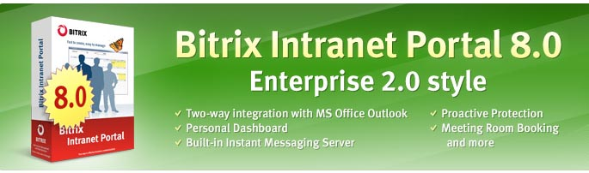
"The new version of the product embodies the principles of Enterprise 2.0. We call them “Three Cs” - Collaboration, Communication and Corporate Culture. The perfect integration with MS Office Outlook, built-in instant messaging server, collaboration tools and personal dashboard – they all allow companies to improve business efficiency and enhance decision making.” said Sergey Rizhikov, CEO of Bitrix, Inc.
The Bitrix Intranet Portal 8.0 is a real breakthrough in Enterprise 2.0 solutions. For the first time in IT history, the unique instant messaging server, XMPP/JABBER, has been built right into an Intranet Portal. All you need is to install one of widespread clients for JABBER - Miranda IM, Trillian Pro, Adium or any other, depending on your operating system (Windows, MAC, or UNIX). Connecting through your mobile device also just got easier. Any handset will get along and all you need to do it to synchronize your handset with the portal. Once you are logged in you can see who all are online, chat with colleagues, share files with them and even set your mood status.
Two-way integration with MS Office Outlook – Bitrix Intranet Portal has complete, two-way synchronization with Microsoft Outlook contacts, calendar (appointments) and tasks. Now you don’t need to flip between screens to keep track of your meetings. You can add events to the Outlook calendar and your personal portal calendar will be automatically updated.
Booking a meeting room - Bitrix Intranet Portal 8.0 allows you to see which rooms are available and when, streamline and manage scheduling processes in real-time, request equipment or setup services at the time of booking. It’s a dream come true for anyone who schedules meetings — and anyone who has to attend them.
Personal dashboard – Bitrix Intranet Portal 8.0 allows you to customize the layout of the main and personal user page according to your personal preferences. You can modify the look and feel of the portal page by including different columns such as events, working groups, company news and RSS-feed information about weather, traffic, etc. A few clicks and your personal portal is ready!
Proactive Protection – build in Proactive Protection Module is a robust combination of proactive filter (Web Application Firewall), disposable passwords, fast and effective anti-malware, protection of authorized sessions, activity control, intrusion log, Control Panel page access blocking by IP, Stop List and integrity control tools to defend against the majority of Internet risks.
Check out the Bitrix Intranet Portal 8.0 today with a 30 day trial offer:http://www.bitrixsoft.com/products/intranet/demo.php#tab-trial-link
You can even test a live system – just visit our virtual lab:
http://www.bitrixsoft.com/products/intranet/demo.php
Bitrix Intranet Portal 8.0:
http://www.bitrixsoft.com/products/intranet/index.php#tab-ver8-link
Proactive Protection Module:
http://www.bitrixsoft.com/products/cms/features/proactive.php
* * * * *
About Bitrix
Bitrix, Inc. specializes in the development of content management systems and portal solutions for managing web projects and multifunctional information systems on the Internet. Bitrix specialists, by their considerable efforts and skill, developed the Bitrix Site Manager software—a standalone application that provides complex web solutions. This software tech-corp was established in 1998 by a group of IT specialists. Bitrix continues to hold a leading position in the web development market, always offering high-standard solutions to its clients and partners.
Contact Details: Bitrix, Inc
901 N. Pitt str, Suite 325
Alexandria, VA 22314
+1 (703) 740-8301
info@bitrixsoft.com
http://www.bitrixsoft.com
Toll Free (U.S. and Canada only):
1-888-5BITRIX (1-888-524-8749)

