DragonFire Racing Takes Over Round 3 and 4 in Lucas Off Road Racing Series
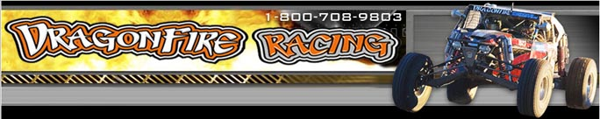

Released on: May 20, 2009, 5:03 am
Author: Dragon Fire Racing
Industry: Automotive
Team takes positions in UTV, Unlimited 2 and Unlimited UTV and is poised for podium performances
(Mesa, Ariz.) May 18, 2009 – DragonFire Racing, a leader in custom performance racing vehicles, accessories and custom racing performance parts, today announced that its team took top finishing positions at the Lucas Offroad Racing series in Surprise Arizona earlier this month. Saturday started with Jerry Welchel winning Unlimited 2, Todd Romano taking third in Unlimited UTV and Hans Waage taking first in Limited UTV on Sunday.
"It was some amazing racing and thanks go out to my staff and friends for making it all happen ," said Todd Romano, spokesperson for DragonFire Racing. “We are in a great position to take three different point championships and are excited with the progress the team is making. The weekend would not have been a success without the help of our sponsors: Team Green Kawasaki, FOX Racing, ITP Wheels and Tires and Gear One.”
The Lucas Off Road Racing Series (LOORRS) combines the traditions of midwest, short course off road racing with a West Coast influence. LOORRS brings intense side-by-side action on tracks that test the most seasoned racers. The 2009 LOORRS season features tracks in Lake Elsinore, Calif., Primm, Nev. And Surprise, Ariz.
DragonFire Racing is an industry leader in the performance racing field and a one stop shop for fabrication, paint, performance and protection for stock and custom ATV, Side-by-Side and other off road racing vehicles. In addition to the Yamaha Rhino parts, racers can find a wide selection of ATV exhausts and side-by-side parts, for all major brands including the Polaris Razer, Kawasaki Teryx, Arctic Cat Prowler and Honda Big Red parts.
With a 10,000 square foot corporate facility and newly opened retail facilities in Lake Havasu City, Ariz. and San Diego, Calif., DragonFire Racing has grown to be a reliable and preferred solution for outdoor racing enthusiasts. For more information on the Yamaha Rhino 700 EFI or DragonFire Racing, please visit http://www.DragonFireRacing.com.
About DragonFire Racing
DragonFire Racing is a leader in custom racing performance parts and accessories forYamaha Rhinos Performance, Sand Rails, Pre-Runners, Arctic Cat Prowlers, Polaris Rangers, Kawasaki Teryx, Side X Side parts, ATVs withheadquarters in Mesa, Arizona. Focused on building performance accessories and turnkey race vehicles, DragonFire Racing delivers high performance parts and vehicles to customers and dealers worldwide. DragonFire Racing has franchises in California and Arizona. For more information, please visit the company's website at http://www.DragonFireRacing.com.
# # #
Contact Details:
Todd Romano
DragonFire Racing
800-708-9803

