Drug Rehab Cites Environment Is A Key Factor To Successful Outcomes In Effectively Reaching And Treating People Suffering From Drug Addiction And Alcoholism

Released on: May 8, 2009, 7:51 am
Author: Mountainside Treatment Center
Industry: Healthcare
Mountainside, known for its unique and highly effective individual drug addiction and alcoholism treatment approach, has evidenced a direct link between the environment in which someone receives their treatment and successful outcomes.
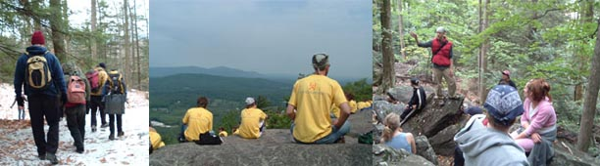
Mountainside Drug Rehab, a leading alcohol and drug addiction treatment center located in Connecticut offers a secluded environment for people suffering from drug addiction and alcoholism. Nestled on 33 Acres at the base of a mountain in the foothills of the Berkshires, Mountainside Drug Rehab provides progressive therapies in an ideal setting for those seeking to recover from their drug addiction or alcoholism. What began 11 years ago as the thesis of accomplished professionals in the drug treatment field has developed into one of the most successful treatment centers - providing quality and effective treatment in an ideal environment for thousands of people.
Mountainside Drug Rehab is guided by its commitment to provide the highest quality care to the leagues of people suffering from addiction. It does this through its compassionate and fully integrated individualized drug addiction treatment program.
Located at the base of their own mountain in Canaan Connecticut, complete with mountain streams, hiking trails to the summit and multiple waterfalls - Mountainside Drug Rehab offers its clients an opportunity to connect with nature and be immersed in the serenity that the beautiful surroundings provide.
An invitation by the White House in 2005 brought this center into the national spotlight, as Drug Czar John Walters announced his curiosity as to how Mountainside Drug Rehab was capable of providing so much to so many. Mountainside cited that the compassionate and individualized approach which it applies to each client that enters its facilities for treatment is strongly complimented by its serene surroundings. By incorporating the natural and expansive surroundings into its daily treatment offerings, Mountainside Drug Rehab offers its clients new ways to relax, connect and focus on issues and teaches them to use treatment tools to build strong and long lasting recoveries.
This recent economic downturn has shown a renewed light on the addiction treatment services of Mountainside Drug Rehab. For more information on the acclaimed treatment program at Mountainside www.mountainside.org in CT or to schedule an admission, please call 800.762.5433.
Contact Details: Mountainside Treatment Center
PO Box 717
Canaan, CT 06018
800-762-5433
http://www.mountainside.org/drug-rehab

