Drug Rehab In CT Sees An Increase In The Number Of Admissions For Prescription Drug Abuse. National Prescription Drug Abuse Is Up To Nearly 80% From The Year 2000 To Nearly 7 Million Americans As Of 2007


Released on: May 15, 2009, 5:18 am
Author: Drug Rehab Mountainside
Industry: Healthcare
Drug Rehab and Alcoholism Treatment Center Mountainside after an analysis of its admissions states that there has been an acute increase in drug rehab admissions for prescription drug abuse. A growing number of these people who are abusing prescription drugs have used the internet to purchase them, this represents a historical shift from the primary source being a local doctor and a shift away from many identified controlled substances.
Drug Rehab and Alcohol Treatment Center Mountainside recently noted a study by the D.E.A. stating that nearly 7 million Americans are abusing prescription drugs. Mountainside has been treating people suffering from addiction to prescription drugs for as long as it has been open. Only now have prescription drugs gained the visibility of various agencies within the US. Prescription drug abuse accounts for nearly 25% of all drug related emergency room visits. Opioid pain killers cause more drug overdoses than cocaine and heroin combined.
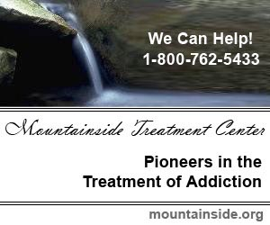
Mountainside Drug rehab and Alcohol Treatment Center is well aware of the dangers of prescription drug abuse and works very hard to include treatment for this type of addiction in its treatment regimen. Mountainside also works very hard with the individual suffering from an addiction to prescription drugs helping them to understand that it can be just as dangerous as any other type of addiction. Often it is believed that because these drugs are prescribed that they are less dangerous than more illicit drugs. This can be a deadly mistake.
If you or someone you know is suffering from an addiction to prescription drugs remember it is never too late. Get help now by calling Mountainside Drug Rehab and Alcohol Treatment centers at 800-762-5433 or visit Mountainside on the web at: www.mountainside.org/drug-rehab
Contact Details: Mountainside Treatment Center
PO Box 717
Canaan, CT 06018
800-762-5433
http://www.mountainside.org/drug-rehab

