Drug Rehab and Alcohol Treatment Center Mountainside Announces Family Treatment and Education Component

Released on: May 1, 2009, 5:56 am
Author: Mountainside
Industry: Healthcare
New York, NY Thursday April 30 2009 - Mountainside Drug Rehab in CT has announced it has expanded its drug addiction treatment offerings to include a family program component. The Mountainside Family Wellness Program will have a focus on understanding the disease of drug and alcohol abuse and how it impacts everyone in a family, constructive problem resolution and continuing care for the whole family.
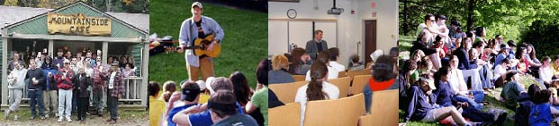
Participants of the Family Wellness Program at Mountainside will learn about various family dynamics and tools that they can use build healthy family systems with someone in recovery from substance abuse. In addition, specific information regarding the family member that has entered drug and/or alcohol rehab is incorporated to ensure a lasting recovery for the client and healthy family dynamic.
A key component of the course is to help understand what behaviors are helpful, expected and harmful to a substance abuser in recovery.
“Families are the hidden victims of drug addiction, enduring enormous levels of stress and pain. They often suffer sleepless nights, deep anxiety and physical exhaustion brought on by worry and desperation. Many times family members carry the burden of a loved ones drug addiction, and it acts as a weight that prohibits them from living healthy lives.
The Family Wellness Program at Mountainside Drug Rehab is designed to help the family recover from these symptoms and become part of the solution. Having a family member in drug rehab or a treatment center for alcohol addiction can be difficult for all that are involved and can often cloud our ability to make the right decision when it comes to helping that family member in to treatment or even more importantly when they get out of treatment. When education is given, with the proper tools and follow up – successful outcomes are more likely to follow.
The goals of this program are:
• To educate families about addiction as a disease
• Encourage participants to examine their roles in the family system
• To provide strategies for identifying and addressing addictive behavior
• Understanding the disease of addiction involving drug and alcohol abuse
• Constructive problem resolution
• Continuing care for the whole family
Contact Details: Mountainside
PO Box 717
187 S. Canaan Rd
Canaan, CT 06018
or visit our website at: www.mountainside.org/drug-rehab

