EZShield introduces its new online storage product, Vault


Released on: May 27, 2009, 3:39 am
Author: Stephanie Demetriou/EZShield
Industry: Internet & Online
Since its creation in 2001, the EZShield check fraud protection program has proven its ability to protect consumers against check fraud. EZShield Vault wants to help consumers rest assured that their confidential paperwork is safe by working as a virtual fireproof safe. By encrypting all information and storing it in the industry’s most secure type of environment, EZShield ensures the safety of every user’s account. Through this secure online database, every user’s most important documents are available from any Internet connection. Consumers will receive reminders and alerts as well as have the peace of mind that all their essentials are safe without taking up any physical or hard drive space.
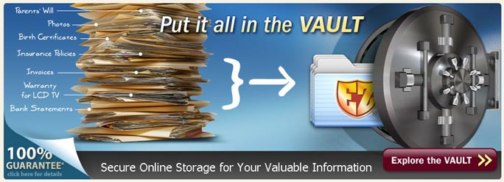
EZShield Vault is an innovative product that works to keep consumers not only organized, but protected against natural disasters, theft, and emergency situations. Vault allows users to upload copies of essential paperwork like social security cards, passports, and financial investments. Additionally, consumers can use Vault to archive all collectibles and belongings or to take inventory of their homes and store it entirely online. Because Vault is accessible from any computer with an Internet connection, users are able to download copies of necessary documents in the event of a natural disaster or emergency.
Aside from working as an online filing cabinet, Vault can also be used as a reminder system. Users can set alerts within the Vault system to remind them of upcoming dates, expirations of warranties, and life events and have them sent directly to mobile devices. Also, EZShield Vault allows up to four additional users per account at no extra cost. This service is simple and easy to use without breaking your wallet. After a free 30 day trial, consumers pay only $4.95 per month to organize and protect their most important documents.
When asked about this unique, new storage system, EZShield Vault Product Manager, John Miller, said, “EZShield has taken security to a whole new level: organizing all your life’s essential paperwork and storing it securely online.” Visit www.ezshieldvault.comtoday and see for yourself!
About EZShield:
With over twenty-five years of experience in printing secure documents and the support of Lloyd’s of London, EZShield has been protecting consumers against fraud since 2001. EZShield has helped to protect the finances and good standings of over fifteen million customers in the more than seven years that it has been in business. The company’s executives understand the misfortune that comes from fraud and identity theft. EZShield wants to help protect consumers from this devastation; thus, it continues to create new products to ensure safety.
Contact Details: 1802 Fashion Court
Joppa, MD 21085
410-679-3300
410-676-3300 (Fax)
sdemetriou@cdi-us.com
http://www.ezshieldvault.com

