Elemis Launches Limited Edition See The Difference Eye Duo
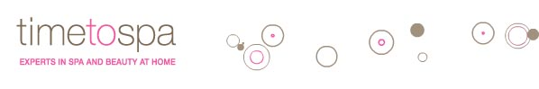

Released on: May 11, 2009, 4:29 am
Author: Elemis
Industry: Retail
Elemis has announced details of its new See the Difference Eye Duo set, featuring products designed to prevent the signs of stress, tiredness and ageing around the eye area.
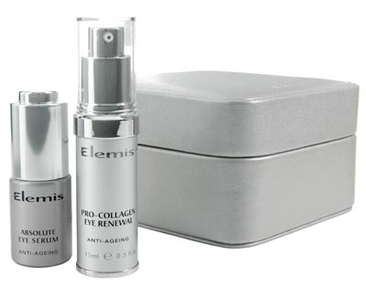
The new limited edition eye care set from Elemis features an Absolute Eye Serum, containing absolutes of rosewood, osmanthus, lavender and chamomile which helps to decongest and reduce dark circles and puffiness around the eye area whilst gently preserving, lifting and refining the eye tissue.
Also contained within the set from Elemis is Pro Collagen Eye Renewal, a lightweight cream-gel that's clinically proven to reduce the appearance of fine lines and wrinkles around the eye area by up to 60% in just 28 days*.
When combined, the Absolute Eye Serum and Pro Collagen Eye Renewal Cream create a synergy of potent seaweeds to help moisturise and increase the firmness of the skin around the eyes.
Both products are recommended to be applied by gently dabbing around the eye contour using the ring finger as this yields the lightest pressure to avoid dragging the delicate skin around the eye. When used as part of a daily regime in the morning and evening the 'See the Difference' Eye Duo can help to protect and repair the skin around the eyes, preventing signs of stress and ageing.
The 'See the Difference' Eye Duo is a strictly limited edition and will only be available from the 4th - 31st May at spas, salons, selected retail outlets nationwide and online, and comes presented in a faux leather jewellery box.
Notes to Editors:
*Data taken from independent clinical trials carried out in 2005
About Elemis:
timetospa (commonly referred to as Time2Spa) is the official online store for Elemis, the pioneering British spa and skin care brand.
Elemis is proud to partner with over 1200 luxurious spas and salons, 130 lavish cruise ship spas, British Airways Elemis travel spas and over 100 retail stores around the globe. Elemis treats over 5.7 million people each year and it has the single largest influence on trends and developments in the global spa and skincare industry. The successful combination of powerful natural ingredients, cutting-edge formulation technology and proven clinical trials has enabled Elemis to bring to market some of the most influential anti-ageing homecare products and professional spa-therapies the beauty industry has ever seen.
PR Contact:
Joelle Constable
10 Haunch of Venison Yard
Mayfair
London
W1K 5EX
020 7907 2743
+44 (0)20 7907 2750
www.timetospa.co.uk

