Find Great Graduation Gifts at Lauren Klein Jewelry


Released on: May 27, 2009, 3:58 am
Author: Lauren Klein
Industry: Retail
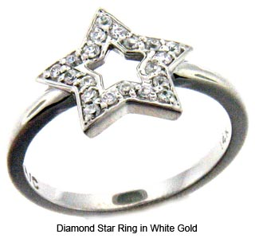
Top online jeweler offers 10 percent discount on purchases
New York City, May 2009 – Lauren Klein, a leading online retailer of designer jewelry, offers a range of jewelry styles for every taste and budget this graduation gift-giving season. Gold or silver, with precious or semi-precious stones, a gift from Lauren Klein’s selection of uniquely designed fine jewelry and costume jewelry makes a memorable keepsake for years to come. The value of precious metals makes jewelry a desirable gift as well as a sound investment.
“The graduation ceremony symbolizes a rewarding personal and professional achievement that results from hard work and dedication,” said Sarah Leight, manager, Lauren Klein. “Such a special occasion merits a celebratory gift that is both beautiful to wear and something that the recipient will cherish. Gift givers can count on us to deliver the high quality and service of a fine jeweler, with convenience and competitive pricing available only online.”
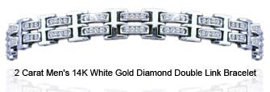
Adorn that special graduate with a beautiful yellow gold honeycomb pendant necklace or coronate her with a white gold and diamond crown ring fit for royalty. If a gilded lily is over the top, consider a rose gold and diamond rose ring instead. Affordable baubles include a turquoise enamel and CZ Lauren G Adams bangle to brighten up any outfit.
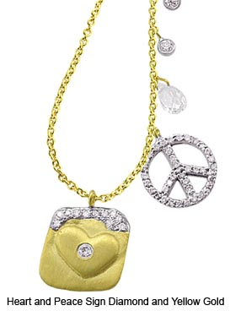
Lauren Klein specializes in all types of jewelry — whatever the style, Lauren Klein has it all. From traditional diamond jewelry to trendy fashion jewelry, Lauren Klein carries only the best selection of women's jewelry -- rings, earrings, necklaces, bracelets, and anklets -- and men's jewelry, at the most competitive prices. The company’s new Monogram Collection offers personalized jewelry for that extra special touch.
The finest collection of jewelry available to the public is also backed by Lauren Klein’s incomparable experience rooted in the fine jewelry industry. As a customer-focused company, Lauren Klein strives to bring the highest quality products directly to consumers to ensure their satisfaction is exceeded. With more than half a century of heritage in the diamond industry, this family operation began its ecommerce business on eBay and Amazon. After great success, Lauren Klein showcases its entire jewelry collection on Laurenklein.com.
For a limited time, Lauren Klein is offering a 10% discount off all items. Please use promo code “Grad09” at checkout to receive the discount.
About Lauren Klein
Lauren Klein provides designer jewelry at affordable prices, bringing 55 years in the diamond business to online shoppers. At Lauren Klein, we control the entire process from source to final product while maintaining the highest quality so we can pass the savings on to customers. Lauren Klein has served thousands of satisfied customers and our experienced customer service representatives are ready to assist you with our vast collection, which ranges from basic solitaire necklaces, gold necklaces and morganite earrings to diamond rose gold rings andtrendy and chic color stone jewelry. Call us toll-free at 1-877-215-6779 or email us at Laurenkjewelry@aol.com. For more information, please visit www.laurenklein.com.
# # #
Contact Details: Sarah Leight
Lauren Klein
877-215-6779

