Five Unique Gifts for Expecting Mothers Includes New Technology That Enhances Pre-natal Bonding


Released on: May 1, 2009, 5:41 am
Author: Runaas Resources LLC
Industry: Healthcare, Small Business
HOUSTON – April 30, 2009 - As an expectant mother, her first official Mother’s Day doesn’t have to be next year, after her special delivery arrives. Here are five unique ideas to make this Mother’s Day special for the expectant mother.
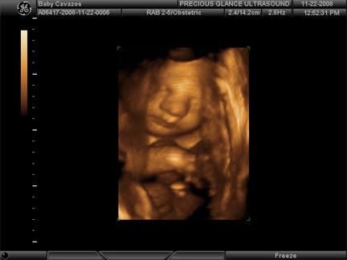
Precious Glance, a leading imaging boutique, can help celebrate motherhood in all its stages. Its premiere service is its 3D and 4D ultrasound technology. Unlike traditional, black-and-white 2D ultrasounds that show only the skeletal outline of the child, 3D and 4D ultrasounds share the baby in greater detail. 3D ultrasounds show the baby’s tissue, so the result is more like the baby’s first picture. Each contour of the baby’s face can be seen in 3D, which can be enhanced in red tones for further personalization. 4D ultrasounds actually show real-time movement, offering an entirely different bonding experience.
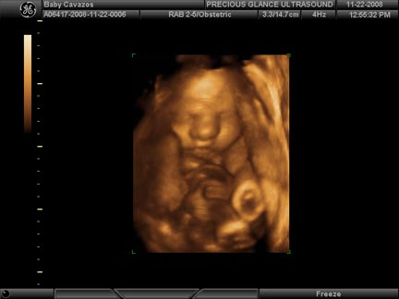
“Our 3D and 4D ultrasounds provide exciting, meaningful ways for mothers to start getting to know their babies – the ultimate Mother’s Day gift” said Chastity Jones, owner of the ultrasound studio . “We offer highly-specialized services to help a mother celebrate one of the most meaningful, intimate times in her life.”
Precious Glance offers gender checks and photography packages, preserving the memory of the expectant mother in all her glory.
Mothers often experience aches and pains like nothing they’ve ever had before. Why not surprise her with hiring a pre-natal massage specialist to ease her discomfort and help her relax?
Throwing a baby shower? Consider Baby Cakes Diaper Design, whose creative specialists concoct decorative, tiered cakes made of diapers and sprinkled with gifts and trinkets guaranteed to make her shower memorable.
Sometimes mom doesn’t have to leave her house to enjoy her gift: If she’s encouraged to stay off her feet, why not hire a concierge to pet-sit, grocery shop, or even run errands for her?
Remember: There’s no reason to wait until next year to start celebrating Mother’s Day if she’s expecting today. She can celebrate the fact that she’s expecting this year, commemorating a time in her life in a way that can’t ever be replicated.
Contact Details: Candace Runaas
Runaas Resources LLC
P.O. Box 130105
The Woodlands, TX 77393
281-257-4431 (W)
281-257-4841 (F)
info@runaasresources.com
www.runaasresources.com

