Hazmat Training Comes to Irvine


Released on: May 29, 2009, 7:55 am
Author: Environmental Resource Center
Industry: Environment
May 29, 2009 - When workers handle hazardous waste or ship hazardous materials, training is not just a good idea, it’s the law. According to the Department of Toxic Substances Control, workers who handle hazardous waste must be trained annually, and the federal DOT requires that workers involved in the shipment of hazardous materials be trained at least every three years.
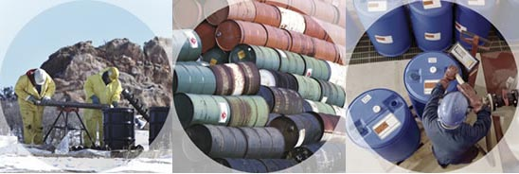
Environmental Resource Center®, the leading provider of environmental and safety training, will present the mandatory training in Irvine on June 9 – 11, 2009 at the Holiday Inn, Orange County Airport.
Hazardous Waste Management - CA: The Complete Course will be taught on June 9 and 10.
Hazardous Materials Certification Training for DOT 49 CFR Transportation Regulations will be taught on June 11 at the same location. Classes begin at 8am and end at 5pm each day.
Registration for the training is available by calling 800-537-2372 or at http://www.ercweb.com/classes.
Now in its 28th year, Environmental Resource Center® trains not only thousands of industry personnel every year, the company also trains personnel from most of the state and federal agencies that enforce the regulations.
Contact Details: Jeannette Karnofsky
Environmental Resource Center®
101 Center Pointe Drive
Cary, NC 27513
919-469-1585; Fax: 919-342-0807
jeannettek@ercweb.com

