High Performance Car Tuning Parts Just Got Easier To Source At The Right Price

Released on: May 7, 2009, 9:58 am
Author: Waynne Smith/TorqueCars
Industry: Automotive
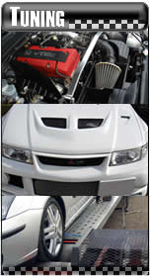
TorqueCars have a fine online reputation for giving unbiased and practical advice to the car tuning and car styling community. TorqueCars now announce the exciting launch of a new online car parts shop.
As well as offering big name performance parts the shop offers a wide selection of car styling parts to cover subtle interior modifications to full exterior styling. You will also find a wide range of alloy wheels in the very latest styles and colours.
The aims of the shop are to provide great value performance parts. A wide range of parts is provided and covers the casual car modifier looking to improve his car in subtle ways for road use all the way up to high performance track day parts.
You will find all of the big name brands in the shop and the search facility allows you to see which parts are available for your car. The site also contains feedback and customer ratings on each product which helps the decision making process.
Order fulfillment is provided by POTN, an established online car parts provider, and benefits from their network of contacts and suppliers.
TorqueCars owner Waynne Smith says "We are very excited by this partnership and it has already been very well received by our car tuning community. It took a long time to find a company who had similar aims and aspirations to ourselves and together we have created, what we hope will be, the ultimate online car parts store.
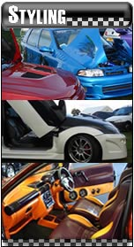
We never rest and are always looking for new innovative products to offer and ways to improve the shopping experience. The latest development is that we can now ship to most countries around the world although orders have to made via email and paid via pay pal."
With the release of the latest Fast and Furious film there has been a big increase in interest for tuning cars. The partnership between TorqueCars and POTN certianly couldn't have been better timed.
"At POTN.COM we are always looking to form partnerships with other businesses that will offer our customers a richer experience. TorqueCars is an excellent example of a business that gives car enthusiasts information and advice which is of a really high standard. It is an absolute pleasure to associate ourselves with them." - Nick Morton. Managing Director. POTN.COM
It is impressive to see such success in the current economic climate but it goes to show that if you offer a good quality product at the right prices you can easily buck the trend. The credit crunch does not appear to be preventing car enthusiasts from making the most of their cars. In fact it may well be helping as people avoid replacing their car and look for ways to upgrade its performance and handling. To see the full range of products and browse the store go to http://torquecars.potn.com
Contact Details: http://www.torquecars.com
http://www.torquecars.co.uk
http://torquecars.potn.com
webmaster@torquecars.com
Waynne Smith
TorqueCars,
Delpech Suite,
The Limes Business Centre
Deal
Kent
CT14 6ER

