Laughingbird's Popular Logo Creator Software Makes Logo Design Easy
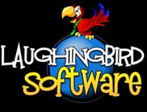

Released on: May 14, 2009, 5:53 am
Author: Marc Sylvester
Industry: Computers
May, 2009 -- The impressive software suite, "The Logo Creator," by Laughingbird Software (www.laughingbirdsoftware.com) allows people of all skill levels to design unique logos for their businesses. The logo maker software also lets business owners make page headers and buttons, and other design features needed for websites, corporate material, and more.
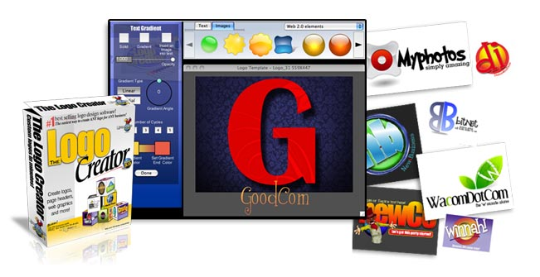
The Logo creator software offers an easy-to-use interface, and a large number of design options, perfect for corporate logos for small business ventures or the entrepreneur wanting to sell logos to interested clients. The logo package is affordably priced as well, allowing anyone to create eye-catching designs in a short amount of time. Its wide array of features and reasonable price have made The Logo Creator the #1 best selling logo maker on the Internet.
The Logo Creation Suite 5.0 includes logo software packages that can be purchased online and downloaded instantly. Each logo set can be used on its own, or in combination with another package to make the process of designing a logo, and other graphic elements, straightforward and quick.
The logo sets available include the Alphabet Logo Edition, Web 2.0 Logo Edition, Corporate Logo Creator, Entertainment Logo Edition, Mascot Logo Collection + Mascots2Go Collection, Sports Logo Edition, Real Estate Logo Edition, Travel Logo Edition, Church Logo Collection, and The Mega Pak Collection. Other products include the Business Card Creator, the Presentation Creator, the Ad Creator, the Web Graphics Creator, and the Avatar Creator.
The Corporate Logo Creator lets individuals create unique corporate logos for websites, blogs, and businesses. The package includes more than 80 professional templates ready to be personalized by adding custom images. Or use one of the 200 built in logo objects that come with the software to put together a logo, header, or button in a matter of minutes.
Essentially, the Logo Creator Corporate Logo Edition makes it possible to add as much or as little detail to the logo design as required. Business owners and webmasters can work at their own pace and build a logo that represents their company's vision perfectly.
For more information about The Logo Creator, contact Laughingbird Software or visit http://www.thelogocreator.com.
About Laughingbird Software: Since launching in 1998, Laughingbird Software has been a top player in the realm of software and design. The Logo Creator Software is the company's most popular product, receiving accolades from consumers and industry professionals across the globe. Laughingbird Software creates logo maker software products for small and large business owners, such as the Corporate logo creator, which makes it easyfor anyone to achieve professional results for an affordable price.
Contact Details: Marc Sylvester
Laughingbird Software
http://www.thelogocreator.com

