Lauren Klein Jewelry Featured in Stylelist Make Up Artist Wardrobe


Released on: May 6, 2009, 12:46 am
Author: Lauren Klein
Industry: Apparel & Fashion
Jewelry worn by Beauty Basics Host Carmindy is available at laurenklein.com
New York City, May 4, 2009 – Lauren Klein, a leading online retailer of designer jewelry, announced today that jewelry worn by Stylelist Beauty Basics Makeup Artist Carmindy, is available online from laurenklein.com. Carmindy, who is also the makeup stylist for TLC’s “What Not to Wear” is seen in video clips sporting jewelry from the Meira T Collection.
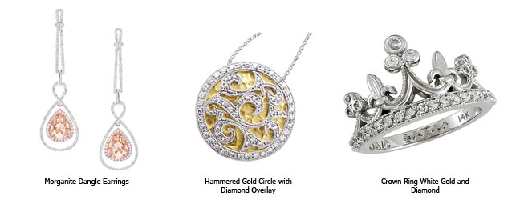
“Millions of viewers seek beauty advice from Carmindy and her influence goes well beyond makeup – it’s about making women look their best naturally,” said Sarah Leight, manager, Lauren Klein. “The jewelry that she wears is reflective of this natural beauty as Meira T designs jewelry that’s ‘designed for a woman by a woman’.”
Lauren Klein specializes in all types of jewelry, no matter the style is, Lauren Klein has it all. From traditional diamond jewelry to trendy fashion jewelry, Lauren Klein carries only the best selection of women's jewelry -- rings, earrings, necklaces, bracelets, and anklets -- and men's jewelry, at the most competitive prices. The company’s new Monogram Collection offers personalized jewelry for that extra special touch.
The finest collection of jewelry available to the public is also backed by Lauren Klein’s incomparable experience rooted in the fine jewelry industry. As a customer-focused company, Lauren Klein strives to bring the highest quality products directly to consumers to ensure their satisfaction is exceeded. With more than half a century of heritage in the diamond industry, this family operation began its ecommerce business on Ebay and Amazon. After great success, Lauren Klein showcases its entire jewelry collection on Laurenklein.com.
About Lauren Klein
Lauren Klein provides designer jewelry at affordable prices, bringing 55 years in the diamond business to online shoppers. At Lauren Klein, we control the entire process from source to final product while maintaining the highest quality so we can pass the savings on to customers. Lauren Klein has served thousands of satisfied customers and our experienced customer service representatives are ready to assist you with our vast collection, which ranges from basic solitaire necklaces, gold necklaces and morganite earrings to diamond rose gold rings and trendy and chiccolor stone jewelry. Call us toll-free at 1-877-215-6779 or email us at Laurenkjewelry@aol.com. For more information, please visit www.laurenklein.com.
# # #
Contact Details: Sarah Leight
Lauren Klein
877-215-6779

