Luxury Wedding Invitation Designers, Thai Silk Box, Re-Launches Online Store


Released on: May 11, 2009, 4:06 am
Author: www.thaisilkbox.com
Industry: Marketing
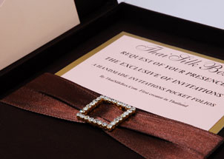
Bangkok, Thailand – May 8, 2009 - Thai Silk Box, a luxury wedding invitation design and supply company, has re-launched their online store and expanded their inventory. Found online at www.thaisilkbox.com, Thai Silk Box’s new storefront provides a larger selection of unique wedding invitations, and an easier-to-use interface for individuals seeking custom-designed wedding invitations.
Entering into 2009, Thai Silk Box was able to experience financial and physical growth in 2008, even amongst the economic downturns experienced throughout the world during that period. With over 1,000 orders processed in 2008, primarily in the United States, United Kingdom, and Australia, this physical and financial increase has purportedly positioned the company to break into the top-class wedding invitation business.
As per a company representative, the reason for the company’s growth last year, and continuing growth this year, is due to the quality of materials used in manufacturing their wedding invitations, their ability to cater to their customers’ exact requirements with custom orders, and their strong, Thai-operated, management team. As Thai Silk Box is located in Thailand, the company plays an active role in fighting against companies who utilize illegal workers, and companies who pay unfair wages to its workers.
Thai Silk Box’s new storefront, and additional inventory, is available for viewing atwww.thaisilkbox.com
About Thai Silk Box
Established in 2002 by Asia Business Alliance Co. LTD, an international trading company, Thai Silk Box offers high-end wedding invitations and custom, Thai-artesian designed invitations for individuals around the world. For more information on Thai Silk Box, visit their website at www.thaisilkbox.com
Contact Details:
Mr. Anunpas Polnara
ASIA BUSINESS ALLIANCE CO.,LTD.
99/305 M.6 Khumklao Rd., Lumpratiew
Ladkrabang, Bangkok
Thailand
Email: ask@thaisilkbox.com
Phone: +66 2636 5266
Website: http://www.thaisilkbox.com

