Naartjie Announces Summer One Styles for Under 20 Bucks


Released on: May 20, 2009, 4:59 am
Author: Naartjie
Industry: Apparel & Fashion
Receive 25% off all online spring fashions for boys and girls
SALT LAKE CITY, Utah, May 18, 2009 -- Naartjie, the original name in fashionable, kid-friendly clothing, today announced reductions on its Summer One line of clothing for infants and children to $19.99 or less. In addition, Naartjie is offering 25 percent off all online spring styles for boys and girls, valid for online purchases and excludes in-store merchandise.
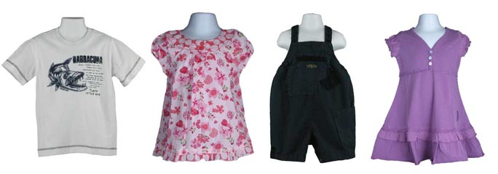
“Memorial Day, which marks the official beginning of summer, is right around the corner, and we’re making a splash with deals on our cool Summer One fashions,” said Joe Norwood, director of marketing, Naartjie USA. “For additional savings and an effortless seasonal transition, customers can take advantage of 25 percent savings on our entire spring collection.”
The Summer One collection by Naartjie takes an understated approach to summer styles with muted soft tones that can easily be worn from spring into the warmer summer months. Moroccan mosaics and batiks from exotic North Africa inspire our girls’ Summer One gypsy floral, gypsy mini and caravan stripe prints. Casual bohemian inspired silhouettes like loose fitting dresses, tunic tops and wide leg pants result in easy, comfortable clothing that kids love to wear. Batik border prints, dip dyes, beading, chunky crocheted lace and muslin add to the ethnic vibe.
Beautiful Moroccan batik prints are the inspiration for the gypsy mini and roma prints used in our newborn girls’ Summer One collection. These simple one-color prints are combined with feminine frills, chunky crocheted lace, and coconut buttons to create a soft bohemian feel. With the growing need to protect our planet, Save our OceanS (S.O.S) is the theme for our newborn boys’ collection. Eco-friendly messages help convey the importance of protecting our oceans, and the submarine stripe cultivates a desire to explore our deep blue seas.
Inspired by creatures of the seas and rivers, our boys’ Summer One collection underscores the message that we are share our planet with millions of underwater friends. The graphics in the line educate kids about some of these sea creatures living below the waves. Graceful sea turtles, shock-producing electric eels and sleek torpedo-bodied barracudas are some of the underwater pals featured in this line. Little explorers take a dive with Naartjie into the deep blue and experience the thrill of nature.
Naartjie designs, colors, prints, and styles represent a truly unique synthesis of European fashion trends with western casual lifestyle. Featuring a dominant focus on natural fabrics that are garment-dyed, pre-washed and pre-shrunk for easy wear, low maintenance and comfort, Naartjie uses a garment dye process that results in a more vibrant color and softer clothing and accessories for precious little ones.
The ultimate in mix and match, Naartjie introduces new colors, prints and styles within a monthly grouping to allow customers to mix and match across the entire assortment. In addition, shoppers can mix and match between Naartjie collections, which showcase the freshest and broadest color assortment in the industry, distinctive detailing, mixing of fabrics, appliqués and embroidery details. Always “Kid-Friendly” design concepts made primarily of natural fabrics that feature weight-right fabrications for maximum comfort and easy care. Each item is designed and constructed for easy-wear comfort, whether the garment is dressed up or dressed down.
About Naartjie
Naartjie was founded in 1989 in Cape Town, South Africa when designer Anne Eales sought an alternative to the limited selection of childrens clothes available as she shopped for her three young boys. From its very conception, Naartjie was about KIDS… playful, vibrant, active, colorful, natural, always changing. We offer great kids clothes and baby clothes, basics and accessories for girls, boys, and newborns to 10 years of age -- all at surprisingly affordable prices. Naartjie’s corporate headquarters are located in Salt Lake City, Utah. Naartjie owns and operates stores in both the United States and South Africa, with new stores opening regularly. For more information, please visit us at http://naartjie.com.
# # #
Contact Details: Joe Norwood
Naartjie
2369 West Orton Circle
Salt Lake City, UT 84119
801-977-7790

