Nail Jack Tools wins Popular Mechanics Editors Choice Award
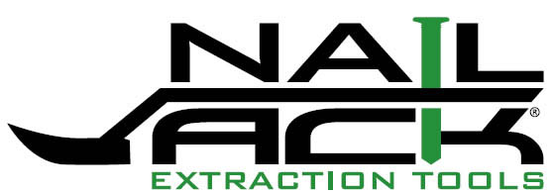

Released on: May 12, 2009, 4:40 am
Author: Mike Foley
Industry: Construction
May 11, 2009 – Nail Jack Tools unveiled their first two nail pulling pliers – the Nail Jack® and Nail Hunter® at the 2009 National Hardware Show in Las Vegas this week and were informed that the Nail Jack has captured Popular Mechanics’ prestigious Editor’s Choice Award.

The publication does not accept submissions for their award, but instead chooses winners from thousands of products based on originality, ingenuity and design. The award recognized Nail Jack Tools for its innovative design in the Nail Jack nail puller – the first hand tool designed as a pliers like device to dig, grab and pull nails, staples and brads. Popular Mechanics called the Nail Jack nail puller a "fresh new hand tool" in a product category that "rarely sees true innovation."
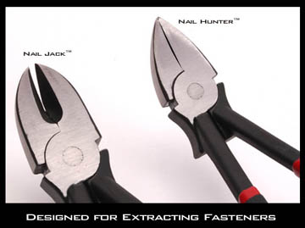
“We are honored to be recognized by this esteemed group of editors for the 2009 Editor’s Choice Award from Popular Mechanics,” says Nail Jack CEO Mike Foley. “The show has been a great opportunity to showcase our tools, and winning an award like this really confirms the need for a new line of tools designed specifically from the ground up to pull nails and fasteners without damaging costly wood products.”
The patented and patent-pending designs of the Nail Jack and Nail Hunter fill a large gap in the retail market and construction industry. Designed like pliers, these unique tools do most of their work with “one hand”, or can be struck with a hammer to dig out a nail, grab a headless brad or nail with their jaws while utilizing a built in fulcrum. The family of tools is specifically designed to pull nails, staples and fasteners with efficiency – saving time and money.
The Idaho-based company founded in 2006 unveiled the Nail Jack tool line at this year’s National Hardware Show. For more information, please visit the company’s website at www.nailjack.com or call the company at 1-877-PULL-NAIL (or at +1-208-928-6426).
Contact Details: Mike Foley
PO Box 1005
Hailey, Idaho 83333
Tel: +1-208-928-6426
Fax: +1-208-445-0285
www.nailjack.com
info@nailjack.com

