New product for Menopause Night Sweats


Released on: May 14, 2009, 5:31 am
Author: Bedfan
Industry: Healthcare
Night Sweats a memory of the past for many menopausal women and Hot Sleepers
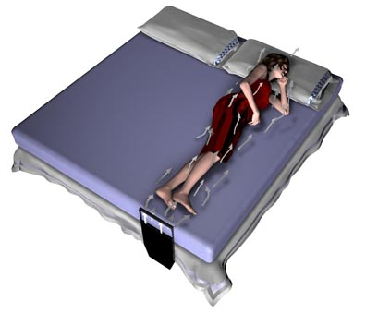
(Boerne, Texas ) : It's a new product that is designed to stop night sweats before they start. As we sleep -- or try to -- our body generates heat that is absorbed into the sheets and mattress. When a night time hot flash occurs, our body is seeing excessive skin level heat. That heat will lead to sweating (night sweats) unless you are able to cool yourself down fast. The Bedfan Personal Cooling System will keep your body cool, remove the built-up heat and cool your bed at the same time. This is accomplished by delivering a soft breeze that flows along your body. The Bedfan is a simple system that is hidden at the foot of your bed to deliver a gentle flowing air between your sheets. This gentle breeze keeps the body and bed cool enough to stop night sweats. No more nighttime tossing and turning, or changing clothes and sheets due to sweating. Menopausal women rejoice night sweats are over, the Bedfan is here. (How Bedfan works: http://www.bedfan.com )
The Bedfan is capable of moving up to 100 Cubic Feet of air each minute but can be dialed down to create an incredibly gentle breeze as well. The unit comes with a compact "Speed Controller" that can be placed under the pillow or on a bedside table giving you full control of the airflow. The Bedfan is a breeze to use and install, and is designed for an extremely long service life.
Most fans, like a ceiling fan, simply circulate air around the room. Up to now, many people used oscillating fans or rigged-up clip-on fans to combat the heat problem. But the Bedfan is the only fan specifically designed to deliver a gentle breeze between your sheets, right where it is needed to end night sweats. If a couple finds that one sleeps hotter than the other, the hotter sleeper can use a Bedfan to keep himself or herself cooler without interrupting the partner's sleep.
" I had seen the options available for hot sleepers to end night sweats and found that there was truly a need. In the case of Menopausal women there were very few options other than drugs methods to absorb sweat while they tried to sleep.” Says the Bedfan inventor, Kurt Tompkins. “The Bedfan is able to stop night sweats from ever starting this is accomplished by keeping the body and the bed cool.” Not only are people sleeping cooler at night but they are actually saving hundreds of dollars a year on their electric bills. “I knew it was working when my mother in-law, started sleeping throughout the night without waking. Something that menopause had not allowed her to do for the last three years.
The Bedfan sells for $89.95 and is available online at: www.bedfan.com
Contact: Kurt Tompkins
Tompkins Research
1472 CR 268
Snook, TX 77878
Phone 210.632.8280
Fax 979.272.1339

