Online Do It Yourself Franchise Documents - Lowest Priced Franchise Kits and Documents Online
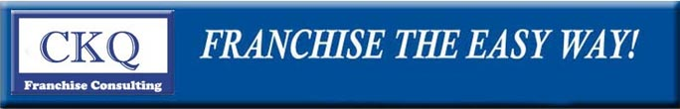

Released on: May 7, 2009, 9:29 am
Author: Franchise the Easy Way
Industry: Small Business
Franchise the Easy Way has published on their website:
www.TheBusinessStartUpKit.com
The Lowest-priced Franchise Kits and Franchise Documents available Online (even lower than E-Bay)!
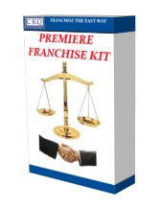
Since Franchise the Easy Way entered the market three years ago, it has lowered the cost of franchising materials 300%. Ask any of their competitors!
Offered on their website are some of the hardiest to find Franchise Documents. Documents such as the Master Franchise Area Development Agreement and an International Franchise Agreement.Find that anywhere else if you can?
Franchise Disclosure Documents
USA, Canada, New Zealand, Australia
Coming soon are Franchise Documents for the United Kingdom for ONLY $49.00 This is the lowest price anywhere in the world for Franchise Documents regardless of the country! The UK Franchise Disclosure Document is an International Franchise Agreement with special wording for the UK. Such areas as VAT are included for the Franchiser.
These Franchise Documents can be purchased in order to support the Novice Franchiser in setting up his Franchising Corporation or the more adventurous Franchiser looking to expand into International Markets. TheBusinessStartUpKit offers it all in nice well thought out Franchising Kits.
For the more timid they also offer On-site at your location Franchising Help for $6,500. You can have one of there Franchise Consultants Help Franchise your business in two weeks! The cheapest and quickest Franchise Consulting in the Business!
www.TheBusinessStartUpKit.com/ or E-mail: sales@thebusinessstartupkit.com and for
two weeks on site Franchise Help see:
http://www.thebusinessstartupkit.com/newconsult.html
Contact Details: Franchise the Easy Way
CK Quarterman
PO Box 7641
Florence, SC 29502
(864)567-6863
ckquarter@hotmail.com
www.thebusinessstartupkit.com

