Photographers Give Medelita Lab Coats an Excellent Rating

Released on: May 19, 2009, 7:23 am
Author: Medelita
Industry: Apparel & Fashion
Innovative medical apparel company produces high performance lab coats that are also highly photogenic
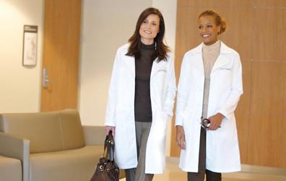
SAN CLEMENTE, Calif., May 18, 2009 -- Medelita™, maker of breakthrough medical apparel for female clinicians, has developed high performance women’s lab coats that are flattering to the female figure and in photographs. In addition to standing up to the daily rigors faced by healthcare professionals – long hours, fluorescent lighting, blood and fluid stains – the Medelita lab coat looks great when worn for headshot photos, graduation ceremonies and staff portraits, all of which warrant a polished, just-pressed appearance.
“In designing the Medelita lab coat, we put all of our energies into the fit and the fabrics’ performance – we were not trying to win any beauty pageants here,” said Lara Manchik, founder, Medelita LLC. “But we’ve come to learn that, due to the high quality fabrics and finishing we use, our lab coats and scrubs photograph very well, both for still pictures and video.”
Enhancing the natural beauty of its wearer both on and off camera, the Medelita lab coat is made from 100 percent brushed cotton with a matte finish that eliminates glare and unwanted reflection that is characteristic of synthetic fibers. Medelita scrubs, constructed from high quality fibers (85 percent virgin polyester and 15 percent cotton), also reduce shine and photograph well. Both have carbon brushed finishes that distribute light evenly to prevent reflection and produce more flattering photographs.
The Medelita lab coat has a supporting role in the CBS Television series “The Doctors,” as part of the wardrobe ensemble for Dr. Lisa Masterson. The show’s costumer chose the Medelita lab coat over mass produced unisex lab coats often masquerading as “designer” lab coats. The Medelita lab coat maintains a polished, professional appearance, slimming effect and flawless performance under the scrutiny of television sets, high definition cameras and the glare of studio lighting, which can bounce off the fabric, creating an undesired shine on one’s face.
Made from high-denier, 100-percent brushed cotton, Medelita lab coats are designed specifically for women with a focus on fit and function. The tailored lab coats have a feminine shape with rounded lapels, a hidden inside pocket, traditional side slits, and French finish inside seams. The fluid-resistant Medelita lab coats are available in sizes 0 to 16, with optional custom embroidery.
In addition to high quality lab coats, Medelita provides a line of performance women’s healthcare apparel, including clinician scrubs and nursing scrubs, which are available for purchase at www.medelita.com.
About Medelita
Medelita has one purpose: to reinvent the way women of all healthcare professions present themselves at work by offering the highest quality, best fitting, and most comfortable medical apparel available, including lab coats , women’s lab coats, women’s scrubs and medical scrubs. Medelitacaters to professional women who want their uniforms to embody the poise and confidence already displayed from within. For more information, visit our website at http://www.medelita.com or call (877) 987-7979.
# # #
Contact Details: Joe Francisco
Medelita LLC
joe@medelita.com
(877) 987-7979

