Rotary Position Sensor From Cherry Is Completely Non-Contacting


Released on: May 20, 2009, 4:32 am
Author: Cherry Electrical Products, Inc.
Industry: Electronics
Pleasant Prairie, WI - Cherry's new AN9 series dual-output rotary position sensor is electrically and physically non-contacting, making it ideal for applications where high reliability and uncertain physical tolerances are involved. Its dual output design offers an additional dimension of reliability, allowing a connected controller to diagnose potential problems in the sensing system.
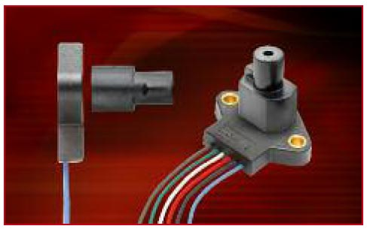
The sensor output is programmable, but it is available in standard output ranges from 0-45 degrees to 0-360 degrees. Its non-contacting nature means that unlimited rotations are possible. Designed for automotive and off-road environments, the sensor is also sealed to IP68 for resistance to water immersion.
The AN9 eliminates the most common cause of rotary position sensor performance problems by removing the mechanical interface between rotating shaft and sensor. In Cherry's unique design, a rotating member mates to a separate magnetic actuator. This means that mis-alignment or changes in the shaft position will not physically impact the sensor. While potentiometric sensors may suffer from wear or dither and traditional non-contacting sensors may experience binding or jamming, the Cherry AN9 sensor is vulnerable to none of these potential failure modes.
The Hall-effect-based AN9 offers a 5vdc ratiometric output. It is suitable for a wide range of applications, including: steering wheel position sensor, shift-by-wire sensor, variable valve timing position sensor, and pedal position sensor for braking and acceleration.
For further information, visit http://www.cherrycorp.com or call 262-942-6500.
About Cherry
Cherry, a brand of ZF Electronics Corporation, provides high-performance sensors, standard and custom electrical switches, and computer keyboards for the worldwide automotive, computer and consumer/commercial OEM markets. ZF Electronics has offices and factories in Germany, England, France, Australia, Czech Republic, Mexico, Hong Kong and the United States.
Contact Details: Steve Hugener
Cherry Electrical Products, Inc.
262/942-6679

