Sandbox Couture Announces the Arrival of Baby Star Organic Clothing
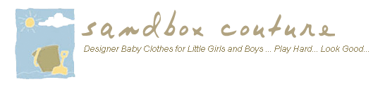
Released on: May 28, 2009, 4:09 am
Author: SandboxCouture.com
Industry: Apparel & Fashion
Online children’s boutique carries environmentally friendly natural baby clothes with formaldehyde-free dyes
Rancho Santa Margarita, Calif., May 2009 -- Sandbox Couture.com, a popular online children's boutique retailer of baby clothes, girls clothes and baby gifts, today introduced the addition of Baby Star organic children’s clothing. The addition of Baby Star organic baby clothes complements SandboxCouture’s existing cadre of quality, brand-named children’s wear while answering the growing demand of safe and eco-conscious children’s products.
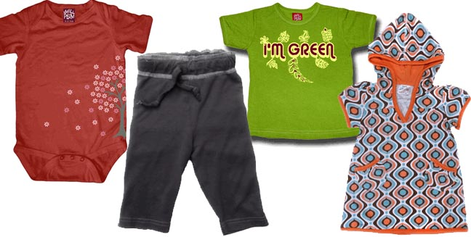
"Environmentalism isn’t just a trend, it’s a mandate if we’re going to leave any kind of legacy for our youngsters," stated Sam Brown, spokesperson for Sandbox Couture. “The use of sustainable, non-toxic materials with a safe yet vibrant pigmentation process is what parents are seeking. With summer around the corner, they want only the safest, most natural materials close to baby’s delicate skin, which will be more exposed in warmer weather. Baby Star organic clothing combines fun and timeless designs with comfort and washable, easy care instructions for busy families.”
The collection features whimsical prints and batiks paired with boys and girls one-pieces, separates, dresses, hooded towels, bibs, blankets and burp cloths, and crib sets. From Buddha kimono sets and sleepers to hooded suits, these organic pieces feature super soft cotton and Baby Star’s unique designs. Crib bedding, diaper bags and burp cloth sets make for great baby and baby shower gift-giving.
Known as the source for quality children’s clothes and couture fashions for babies and children, Sandbox Couture has provided busy parents -- and a loyal following of couture shoppers and celebrity moms -- a convenient outlet for quality, value and fashion savvy designs for little boys and little girls. Sandbox Couture has developed a reputation for offering couture children’s fashions, at prices that parents will appreciate. From unique designs to the hottest trends, Sandbox Couture's collection of designers offers the convenience of online shopping and the benefits of online savings.
Sandbox Couture is now serving the global community with its fashion forward trends and name brand selections. International shipping rates apply. For additional details, please visit www.sandboxcouture.com.
About Sandbox Couture
Sandbox Couture is an online children's boutique retailer, providing baby clothes, baby gifts and unique children’s clothes. The company takes pride in hand selecting products from top designers, thereby ensuring quality and contemporary style. Sandbox Couture’s philanthropic contributions and socially conscious business practices are at the forefront of the company’s ideals and corporate culture. Founded in 2005, Sandbox Couture is privately held and headquartered in Rancho Santa Margarita, CA. For information about Sandbox Couture, please visit the company's web site at http://www.SandboxCouture.com.
###
Contact Details: Sam Brown
949-459–2505
pr@sandboxcouture.com

