SilverDoor announces further expansion plans for UK portfolio
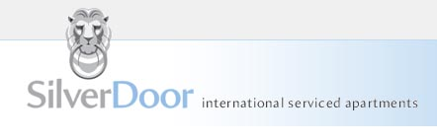

Released on: May 5, 2009, 4:48 am
Author: SilverDoor
Industry: Real Estate
SilverDoor has added new serviced apartments in Leeds to its UK portfolio and as well as new serviced apartments in Newcastle, following a demand by Northern corporate companies. In addition to these two cities, SilverDoor has also expanded with new serviced apartments in Cambridge and Bristol.
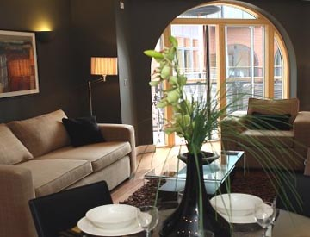
Leeds has been branded as the 'Knightsbridge of the North' and is home to many financial organisations and major corporate companies. Serviced apartments in Leeds have grown in popularity over the past few years and SilverDoor now have six developments in and around the city centre. St George Apartments are located a short walk from the mainline station and city centre on a cosmopolitan street close to many of Leeds bars, restaurants and cafes. Each one and two bedroom apartment is stylishly decorated and furnished, with features including a fully equipped kitchen, private balconies and complimentary broadband internet. A number of additional services such as airport transfers, in house catering and access to a nearby gym are available at an extra charge.
Newcastle has also seen a rise in the number of apartment developments and serviced apartments in Newcastle is a growing market. SilverDoor now has sixteen apartment developments in Newcastle and the surrounding area, with a range of one and two bedroom properties.
Grey Street Apartments is located at the top of Grey Street in Newcastle city centre. The modern, two bedroom penthouse apartment offers stunning views of the city, overlooking the distinctive curve of the road which runs down towards the Tyne River. Laid out in a duplex style, this contemporary Newcastle serviced apartment features a lounge, dining room, a fully fitted kitchen and a double bedroom, with a main bathroom on the lower level. A spiral staircase leads to a master bedroom and en suite bathroom.
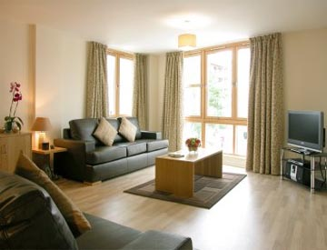
Grey Street was voted as the best street in Britain by Radio 4 listeners a few years ago and is home to Grey's monument and Newcastle’s Theatre Royal, as well as some of the finest Georgian architecture in the city.
Cambridge and Bristol are becoming major business destinations and serviced apartments in both areas are becoming increasingly popular.
"We receive many enquiries for these areas and at the moment we feature eight serviced apartments in Cambridge and fourteen serviced apartments in Bristol. These developments cover the city centres and surrounding areas giving SilverDoor a good coverage in both areas," said Marnie Delaney-Parker, Head of PR and Marketing at SilverDoor.
About SilverDoor:
SilverDoor international serviced apartments was incorporated as a Limited Company in March 2000 under its original name of Hotdigs. At the beginning of January 2006 the company changed its name to SilverDoor. The company was formed and continues to be led by managing director Marcus Angell.
SilverDoor boasts an impressive client portfolio which includes many FTSE 100 companies such as RBS, HSBC, Cadbury and MAN Group PLC.
SilverDoor offers serviced apartments in over 160 locations globally such as London, Paris, New York, Abu Dhabi and Dubai. SilverDoor has also just added a selection ofserviced apartments in Manchester and Cardiff to its portfolio.
SilverDoor is based in Chiswick, West London.
For further information, please contact:
Marnie Delaney-Parker
Head of PR and Marketing
SilverDoor
3 Dukes Gate
London
W4 5DX
07903 900 785
www.silverdoor.co.uk

