Steroid Sources Provides Information On the Safe Use Of Steroids
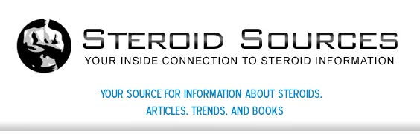

Released on: May 14, 2009, 6:08 am
Author: steroidsources.com
Industry: Healthcare
May, 2009: Steroid Sources, a source for steroids online, provides comprehensive information for those interesting in purchasing steroids. It's important to understand the different type of steroids before deciding what to purchase. First, topical steroids that usually come in ointment or cream form are most often applied to the outside of the body. Other steroids that are available for purchase will enter the bloodstream and can be given by IV, taken orally or injected.

What exactly is a steroid? Steroid Sources explains to its customer that they are naturally-occurring or man-made that are often use for medical purposes. Someone who is anemic (low red blood cell count), men who do not produce enough testosterone and individuals who consistent lose a lot of weight because of illness or major injury. Most importantly, the website dedicates itself to making those visiting the site understand that those steroids that are used for medicinal reasons should be prescribed by a health care professional.
One of the most popular steroids available for sale is anabolic steroids, a synthetic hormone variation of steroids. Anabolic steroids are used most often for increased athletic performance through the growth of muscle mass (which occurs extremely fast). Anabolic steroids remain the most popular variation for those looking to buy steroids from Steroid Sources.
While other websites hope to just sell to you, Steroid Sources provides you important information for your safety while using steroids as well as will answer any additional questions you may have before purchasing. Anabolic steroids will help you perform better by helping you to gain weight, to build muscle mass and to increase your strength as a result of this new muscle. Steroid Sources provides a safe and easy way to buy steroids online.
Ultimately, after choosing to use steroids, it's important that you gain information about the proper and safe use of steroids from a trusted source. Websites such as Steroid Sources will provide you honest information to protect you after looking to buy steroids. No matter the type of steroid you purchase, whether natural or manmade, there are specific limitations on how much steroids is appropriate to take in a given time period. Additional use may cause great physical harm to your body. If additional information is needed other than that provided by Steroid Sources, contact a health care professional.
Another, DHEA, a natural steroid, is often used as a nutritional supplement and can be bought without a prescription. Much like anabolic steroids, these steroids can be purchased from Steroids Sources online. Their professionals can provide priceless information about steroids and help you find what you're looking for.
For more information on anabolic steroids and to buy steroids, visit Steroidsources.com for comprehensive information on how to buy steroids and how to use them safely. This professional website is a trusted source among online steroid sellers. Trust in Steroid Sources today!
Contact Details: http://steroidsources.com/
SS, Inc.
22nd Avenue
P. O. Box 530007
St. Petersburg, FL 33747

