Steroid Sources, A Reliable Source For Steroids Online
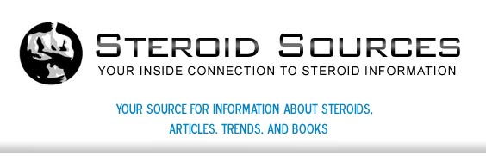

Released on: May 14, 2009, 6:12 am
Author: steroidsources.com
Industry: Healthcare
May, 2009: When looking for a source for steroids online, it's important to find a trusted company to purchase steroids from. When deciding to choose legal steroids, various components go into the decision of what to purchase, from who and when. If someone who is interested in steroids is uncertain of what legal steroids are available, websites such as Steroid Sources have professionals who can provide consumer’s answers that they need to make the best decision for their particular health situation or lifestyle.
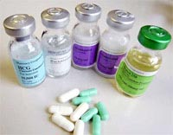
Steroids and legal steroids fall in several categories. Some steroids available on the market are: Corticosteroids, these natural-occurring steroids include prednisone and cortisone Anabolic Steroids, these synthetic hormones are similar to the natural male hormone testosterone and are commonly used for those active in sports or professional or semi-professional athletes. Natural steroids such as testosterone and estrogen.
While steroids such as an anabolic steroid are generally used for curing various ailments and illness, they also are used to build muscle mass. This muscle mass increases strength as well as weight to increase performance in athletic situations. While professional athletes are one of the most popular individuals in society to use steroids, a variety of common folk also are looking for steroids for sale.
Whether someone uses natural or synthetic (manmade), it's important that steroids are used safely. The proper usage and dosage should be determined before beginning to use a steroid whether anabolic steroid or not. Legal steroids always include comprehensive information on how to keep an individual safe while using steroids.
For additional information on legal steroids and steroids for sale, Steroid Sources can provide helpful facts that will help make your decision easier. Steroids for sale on Steroid Sources are available, however it is always suggested that your doctor or a healthcare professional has been consulted before the onset of steroid use begins.
Legal steroids are available on trusted websites such as Steroid Sources. Whether choosing legal steroids such as natural or manmade variations, the website has comprehensive information that will help someone looking for steroids for sale to choose the best option for them. It's always important to follow usage instructions carefully when using legal steroids. The improper use of steroids such as an anabolic steroid can cause serious health problems for steroid users.
For more information on legal steroid, visit Steroid Sources' official website at www.steroidsources.com. For information on steroids for sale, visit the buy-steroids page on the website. For additional information, use the contact page, whether through email or the phone, to get other important questions you have regarding anabolic steroids answered!
Contact Details: http://steroidsources.com/
SS, Inc.
22nd Avenue
P. O. Box 530007
St. Petersburg, FL 33747

