Styles Checks™ gets a new look and widens its selection of check designs


Released on: May 14, 2009, 5:16 am
Author: Stephanie Demetriou/Styles Checks
Industry: Marketing
Since its inception, Styles Checks™ has always offered consumers a wide variety of personal check designs. Styles Checks has earned a place at the top of the check printing industry with a large selection of licensed products including I Love Lucy and the work of Gary Patterson, while also providing simpler and more professional designs. However, after more than a decade in the business, it was time for Styles Checks to have a makeover. By adding over 200 new check designs and accessories through Image by Styles and adjusting the color scheme and branding, Styles Checks now has a much more modern feel.
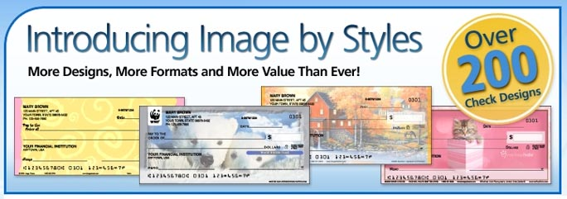
On May 1, 2009, Styles Checks™ launched its redesigned website. The newest addition to the site is the Image by Styles category and all the new check designs, but there are other significant changes as well. To express a more modern look and feel, the site’s colors were changed from dark reds to bright blues and pinks. Additionally, the branding has changed slightly to convey this new and improved appearance. The new Styles Checks™ site has a much cleaner and sophisticated look, making it easier for consumers to locate their desired products on the website. By incorporating drop down menus and graphical navigation, the home page has been improved to coordinate products, categories, and designs. Enhancements to the image preview option and product descriptions make selecting the products that interest you quick and simple. Overall, the site is easier to maneuver and more aesthetically pleasing to consumers.
Whether you have visited Styles Checks™ in the past or if your visit to the new site will be your first, it is sure to be a pleasant experience. Styles Checks™ has taken on a whole new look with a modernized color scheme and new branding for the website as well as additional designs to browse. Brand Director, Mikki Wilson, said, “We are very excited about the new look for Styles. We look forward to the continued growth based on the new site product offerings, designs, and branding.” Visit the site to view everything it has to offer and you are sure to walk away with something you love!
About Styles Checks™:
Whatever interest, hobby, or collection you may have, Styles Checks™ is sure to have something for you. Including checks that feature our favorite personalities, colorful designs, and famous brands, Styles Checks™ is certain to have something you can fall in love with! Visit our site to make your daily banking routine a little more interesting!
Contact Details: 1802 Fashion Court
Joppa, MD 21085
410-679-3300 ext. 2453
410-676-3300 (Fax)
sdemetriou@cdi-us.com

