The Children’s Mutual announces a twist on traditional life insurance


Released on: May 26, 2009, 6:45 am
Author: The Children's Mutual
Industry: Financial
Leading Child Trust Fund provider, The Children's Mutual, has announced the launch of a very different Return of Premium Term Life Insurance policy.
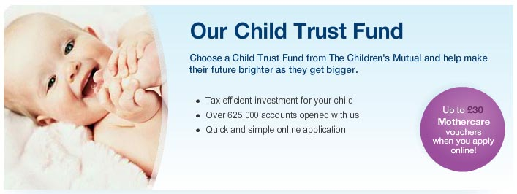
Traditional Term Insurance products ask people to pay regular insurance premiums on the understanding that if the person insured dies during the policy term a payment will be made to the family or executors. But, if the person insured survives the term neither they nor the family will receive anything back.
The Children's Mutual has teamed up with insurance experts ACE Europe Life Ltd to offer customers the ACE Return of Premium Term Life Insurance policy, which gives families the financial security of up to £100,000 cover in the event of death, combined with a guarantee that if the worst doesn't happen all premiums paid will be returned. This ensures that, as well as peace of mind throughout the term, policy holders will have something to look forward to at the end of it too.
Designed to be easy and affordable as well as rewarding, the Return of Premium Term Life Insurance can be applied for online by simply completing 4 straightforward questions to check eligibility. There is no medical to pass and the length of term is selected by the applicant at the time of submission - from 5 to 18 years - to reflect personal circumstances and requirements.
David White, Chief Executive Officer of The Children's Mutual, leading Child Trust Fundprovider, commented: "We are delighted to announce the launch of what we believe to be the only product of this kind in the UK. We have worked closely with ACE to develop a form of Term Insurance that will offer our customers reassurance and value throughout as well as giving them an added reward at term end."
The new ACE Return of Premium Term Life Insurance policy has been created to provide a win-win situation for policy holders - with protection for loved ones should the worst happen, and money back if it doesn't.
Benefits include:
- Peace of mind for the whole family
- Up to £100,000 of cover
- All premiums back if the holder survives the full policy term
- Quick and easy application process
- Variable length of policy - from 5 to 18 years
- Affordable monthly payments
To celebrate this innovative new product, a special introductory incentive is being offered, where policy holders pay just 99p a month for their first 2 months of cover. Additionally, if the partner of a policy holder also takes out cover, then they will pay just 99p a month for the first 2 months as well, plus receive 15% off all their monthly premiums after that.
- ENDS -
Notes to editors
About The Children's Mutual - Home of the Child Trust Fund The Children's Mutual's mission is to help parents, grandparents, family and friends fulfil their hopes for today's children and secure their financial futures. The company specialises exclusively in family-focused finance products, and is currently the choice of 1 in 4 parents for their child's Child Trust Fund.
The Children's Mutual, as an expert in savings for children, made a significant contribution to the Government's Child Trust Fund consultation process and is widely recognised by the business community and press as an industry expert on family finance. This expertise has led several financial institutions and family-focused high street retailers to choose The Children's Mutual as their stakeholder CTF partner.
For further media information please contact:
Stephanie Quantick
The Children's Mutual
PO Box 2067
Gloucester
GL4 3YU
01892 775 348
www.thechildrensmutual.co.uk

