Topshop Announces Barbara Hulanicki Collection


Released on: May 11, 2009, 4:17 am
Author: TopShop
Industry: Retail
Topshop is renowned for working with style heroes of the past, present and future, and this spring marks its coming together with Barbara Hulanicki. Continuing from where she left off in the 70s, Barbara Hulanicki rejoins the fashion world with a new series of clothes for Topshop.
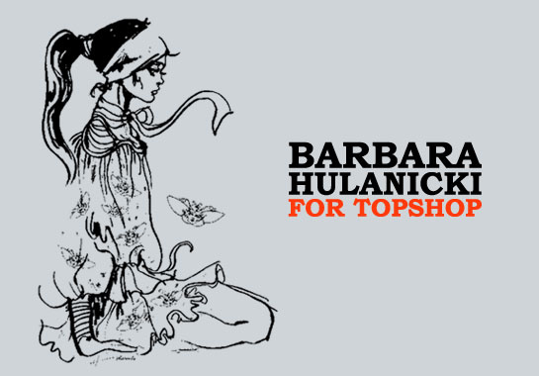
While rich with reminders of Biba in its heyday, the collection is a distinct move away from the pretty designs of the past. Clothes are brought up to date by modern prints and edgier shapes for a new generation of fans, making Hulanicki one of the most influential and inspirational style icons of the 20th century.
Having spent the last 15 years designing furniture and hotels worldwide, Hulanicki has reverted back to her first love of fashion illustration as the starting point for the collection. The enchanting 'ladybug' and 'headscarf girl' designs appear on delicate chiffons, the bold 'enlarged animal print' is splashed over silks and jerseys, and quirky large placement sketches of fashion girls stand out on T-shirts and accessories.
The Hulanicki collection takes on a split personality of Good Girl/Bad Girl dressing.
A playful, floaty silhouette in bright coral, pink and pale turquoise tones characterises the Good Girl. A flirty printed dress with Hulanicki's trademark elegant puff shoulders is echoed by daringly short skater skirts, culottes and playsuits in chiffons and silks. Billowing smock blouses are grown up, while a bright pink 'ladybug' print cropped corset top and coral animal print body are aimed at the younger customer. The dramatic black maxi jumpsuit with tie shoulders is the stand out piece and most reminiscent of the collection's 1970s origins.
A seductive off-the-shoulder body-con dress in lilac jersey with a teasing print on the bust appeals to the collection's Bad Girl. Mini dresses are bandeau or halter neck in figure hugging jersey for a laid-back sexy look, and a cropped suede jacket with matching high-waist hot pants in khaki. The large prints used on these clothes are repeated on several simple jersey T-shirts for a more accessible and casual take on the look.
Beachwear finishes off the womens clothing collection with a 'headscarf lady' printed retro-shaped bikini set and oversized floppy sun hat in either bright or pale pink, and a large beach bag emblazoned with the 'silhouette girl'.
On her collaboration with Topshop Barbara said: "Top Shop has always been the first shopping stop when I am in London. They work in the same fast thinking, 'It won't be there the next time so make a snap decision' attitude that we developed in the 60s and 70s."
Mary Homer, managing director of Topshop added: "It is an honour to be working with one of my own personal fashion heroes. Barbara's approach to fashion is as bold and inspirational now as it was in the 70s. The team has loved working with her and I know our customers will love this collection"
The new Hulanicki collection will be on sale from the end of April.
About Topshop
Topshop was established in 1964 and is part of Arcadia Group Ltd. Sir Philip Green became owner of Arcadia Group Ltd in 2002.
Topshop is continually recognised as being an authority on womens fashion, having won several awards for design reputation and new service. Topshop was the first fashion retailer to show on schedule at London Fashion Week in September 2005 and continues to grow its reputation for supporting exciting new talent at London Fashion Week.
For further information please contact:
Marianna Friedman
Press Officer
Topshop Press Office
Colegrave House
70 Berners Street
London
W1T 3NL
(001) 212 966 9065
www.topshop.com

