Using web copywriting to attract the right customers

Released on: May 11, 2009, 4:09 am
Author: MediaCo (UK) Ltd
Industry: Internet & Online
Good web copywriting can ensure that readers become loyal customers. However, it isn't just about writing the reasons why your business is better than competitors. There is a lot of preparation to go which will help your writing speak to your readers in the most effective way.
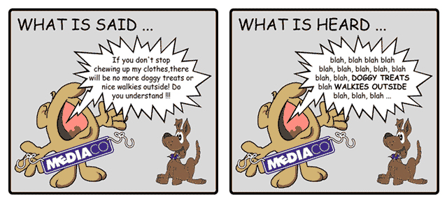
This article will show you how you can create personas for potential clients, which are a useful tool on the road to creating copy which readers can relate to. By putting yourself in your customers' shoes, you will find that effective web copywriting is easier.
When it comes to web copywriting, you have to ensure that you are using language that is appropriate for your audience.
This means before beginning your writing, you should spend some time identifying your main audience. You don't need to survey your current customers - just a little common sense will come in handy.
To help make your writing really speak to the people that visit your site, you should try to develop identities for potential clients. Your clients will vary depending on your industry, so don't be afraid to experiment with the personas you create.
For example, an online investment guide will be geared towards businesspeople with a secure amount of disposable income. You could develop an appropriate persona for a potential client by:
• Searching for pictures based on your client base. This could be anything, such as "businessman", "sports fan", "scientist" or "amateur cook". The possibilities are endless.
• Thinking about your customers' goals. Businessmen may want a healthy return on investment, while an amateur cook may want a healthy recipe using forgotten things from the back of the freezer.
• Judging your readers' knowledge of the subject. If they are an amateur, a cook may be attempting a romantic meal for the first time and will need simple, step-by-step instructions. A scientist will obviously be able to cope with much more technical language and jargon.
• Filling in your example customers' background. This could include giving them a name, age and short biography.
Once you have this information, print your profile along with the most appropriate picture. If you have this beside you as you write, you fill find your web copywriting becomes more geared towards the sort of client that is likely to become a loyal customer.
When you are writing, you should also ensure that you know what is most likely to impress your target audience.
Few people buy into unjustified claims and hype. Be sure to support what you say with testimonials from satisfied customers, as well as facts and figures to show the benefits of your business.
The tone of voice is also very important, and this will change depending on your audience when you are writing online. Whoever your customers are, they will be most likely to buy from a site that speaks to them in a way they can relate to.
Empathise with your readers, relate to them, and you will find you are attracting the customers you want.
Contact Details: MediaCo (UK) Ltd
12 Manhattan Business Park
Dundonald Street
Dundee
DD3 7PY
Phone: 01382 525 220
Fax: 0138 525 221
Email: info@media.co.uk
web: www.media.co.uk

