Vogue Wigs Offers High-Quality Wigs For Low Prices


Released on: May 14, 2009, 6:05 am
Author: VogueWigs.com
Industry: Apparel & Fashion
New York, May, 2009 -- Vogue Wigs is a successful online retailer that sells human hair wigs, synthetic wigs, and African-American wigs for affordable prices. The site also sells costume wigs for parties, premium human hair wigs for special occasions, petite wigs, and lace front wigs.
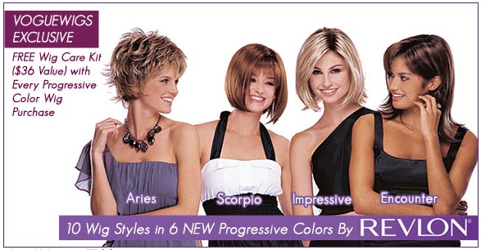
Hair accessories such as hairpieces, hair extensions, and custom wigs can be purchased as well. Vogue Wigs is especially well-known for its ebony wigs, made specifically to benefit African-American customers. In addition, Vogue Wigs provides monofilament wigs for that suffering medical hair loss due to alopecia or cancer.
The company has earned an excellent reputation with customers for providing top brands at everyday sale prices. They even offer discount wigs, hair extensions, and ebony wigs.
The website sells brand name wigs by designers such as Balmain Paris, Elegante, Eva Gabor, Incognito, Lacey, Revlon Ebony, Sepia, Tress Allure, and Wig Pro, for discounted prices not found anywhere else on the Internet. Wig buyers from a wide variety of different backgrounds can find the perfect wig at Vogue Wigs.
Customers can take advantage of free US shipping for purchases over $50, and frequent discounts offered in the monthly newsletter. Products from Vogue Wigs make it easy to save money, and purchases can easily be made online through the website.
The site includes information to help visitors make the right selection when searching for a wig or hair accessories, offering a comprehensive guide that covers a large selection of hair-related topics.
Vogue Wigs is famous for its in-depth customer service and low prices. No other online destination dedicated to hair and wig products offers the same level of service, price, and quality.
The company's costume wig selection is quite vast, highlighting a good selection of
costume wigs designed for special occasions, such as costume parties, Halloween
parties, and theater productions. The costume wigs available for sale are appropriate for a variety of venues and events.
For more information about wigs and hair accessories, contact Vogue Wigs or visit http://www.voguewigs.com.
About Vogue Wigs: Vogue Wigs is an online retailer of wigs and hair accessories for Caucasian and African-American women between the ages of 30-60. The company offers top, brand name wigs and excellent customer service combined with competitive prices. They also offer free US shipping on any orders over $50. Vogue Wigs specializes in ebony wigs, tailored toward an African-American clientele.
Contact Details: Vogue Wigs
http://www.voguewigs.com

