40 Years of Effective Drug Rehabilitation
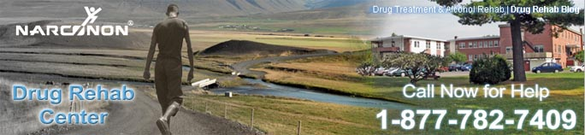

Released on: June 9, 2009, 7:53 am
Author: Narconon Drug Rehab
Industry: Healthcare
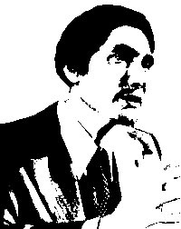
Trois-Rivieres, Quebec – “Well what does he know about it? Has he ever taken a trip?” The Founder of the Narconon drug rehab program made this statement over 40 years ago. He went on to say: “You could very easily put this question to me. And I just wanted to say that I have taken so many trips, for nineteen years, that I could buy out the greyhound bus station.”
Prior to creating the first Narconon therapy group within the Arizona State Prison in 1966, William Benitez was a former heroin addict of nineteen years. Like most former addicts, he had been through many forms drug rehab and drug addiction treatment over the greater part of his life. It was not until he discovered a workable solution to overcoming addiction while being sentenced to prison, when he finally beat his own addiction. After being released in 1968, he was fortunate to be able to deliver, what could be considered, a drug education lecture to the students of Scottsdale High School in Arizona.
When Mr. Benitez gave this lecture he talked of his own experiences; he wanted to give these students the information about what drug addiction was really like. “I experienced these various things you see.” Says Benitez in the lecture. Narconon Trois-Rivieres has put together a short video of the recorded lecture. In this video Mr. Benitez talks about narcotic addiction, and the Narconon program. He shows how raising a persons abilities, and giving that person more abilities will give them the best opportunity to remain drug and crime free. And this worked for Benitez; he was able to successfully rehabilitate twelve out of twelve men who were in the first Narconon therapy group.
If you or someone you know is addicted to drugs or alcohol, and requires help, call our toll free hot line at, 1-877-782-7409, or visit us at, http://narconon.ca/
© 2009 Narconon Trois-Rivières. All Rights Reserved.
NARCONON is a trademark and service mark owned by Association for Better Living and Education and is used with its permission.

