A New Online Bird Watching Community Reaches For The Sky
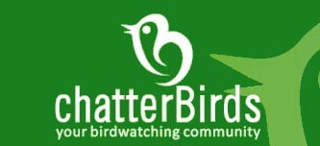

Released on: June 4, 2009, 11:21 am
Author: Paul Searle
Industry: Environment
Cambridge UK June 2009 - ChatterBirds.com is a new online community designed and developed to provide birdwatchers with tools to help share their passion for birds. Bringing people closer together in an innovative style, chatterbirds.com enhances the hobby of bird watching in a dynamic, informative and interactive fashion unique to an online birding resource.
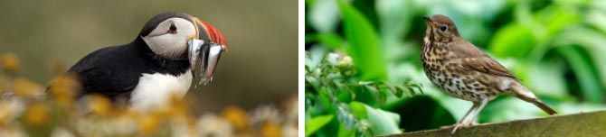
The community offers tools to support the challenges of bird watching, such as the ‘bird identifier’ for confirming species sightings, or the ‘locate species’ function - a search function for species sightings in your part of the world. Other features allow members to store and share images, search a database of birding hotspots, keep an online bird diary, join groups and share birding activities.
In the current global climate where many people may be feeling the pinch, the prospect of spending money on joining fees for a website fees may raise a few eyebrows, but as the chatterBirds community is free to use that makes the decision to join an easy one. With no registration fees, easy to use features and open to anyone with access to the internet, one of the world’s fastest growing hobbies now has its own vibrant, interactive community.
Bird watching is a hobby available to everyone. No matter where you are based, or what your physical ability chatterBirds.com offers every user a sense of involvement.
From the millions of people spending hours each year watching birds in their backyards, to the more experienced twitchers forever chasing that illusive tick for their bird lists, the chatterBirds community provides a meeting point for everyone to interact regardless of level of experience or what part of the world you live in.
So for anyone out there with an interest in birds and nature, or those simply looking to learn more or find a new hobby, the chatterBirds.com community provides the perfect one-stop online resource to enhance your bird watching enjoyment and experience.
Contact: Paul Searle
Web: www.chatterbirds.com
Email: info@chatterbirds.com
Phone: 07812 688365
About chatterBirds.com
ChatterBirds.com founded by entrepreneurs Paul Searle and Zak Jacobs in Cambridge, UK. The unique free online community for birdwatchers is set to be the world’s most dynamic interactive bird watching resource. The community begins the official launch from 1st June 2009 and already has over 300 registered birdwatchers that have taken part during the development and testing phase.

