An Online First: Website Visitors Can Design And Buy Earrings


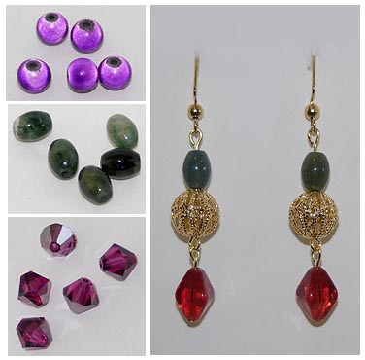
Released on: June 3, 2009, 11:36 am
Author: : Big Cat Fashion
Industry: Apparel & Fashion
Owego, NY June 3, 2009. A brand new experience is now available for internet shoppers. Visitors to the newly launched www.bigcatfashion.com will discover hundreds of different beads, crystals and stones available for designing earrings- online. Customers create earrings by clicking on photographs of design components to add them to their earrings. If they choose, they can purchase their creations. All earrings are priced at fifteen dollars or less.
Big Cat Fashion originated in response to the popularity of beading and jewelry making as hobbies. Says founder Lisa Coniglio, “I thought there might be many people who would enjoy creating their own jewelry, but who didn’t necessarily want to invest in the tools and supplies. The internet offers a great opportunity for people to design virtually, and then buy their creations.”
So far, Coniglio says, business hasn’t been great. “I’ve been selling some- mostly to friends and family.” But, she continues, “I know there are people out there like me who would just love this!”
Visitors to www.bigcatfashion.com use beads, stones, and crystals like those shown below to design unique earrings. An example of earrings designed on the website is shown at the far right.
Contact Details: Big Cat Fashion
740 Carmichael Rd.
Owego, NY 13827
607-972-9606
lconiglio@bigcatfashion.com
www.bigcatfashion.com

