BT Business IT Support Manager Battles Printergeist

Released on: June 8, 2009, 6:45 am
Author: BT Business
Industry: Small Business
UK businesses clocked up a massive 22,000 calls to BT Business IT Support Manager between January and March 2009, and sales doubled over the period, as more small businesses look to down-the-line IT support rather than risk downtime during the recession.
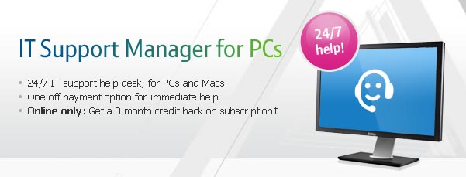
Over the three months, the bulk of calls were requests for network and mail assistance, with email help triggering more than a quarter. Virus and security issues alone prompted nearly 10 per cent of BT Business IT Support Manager help desk contact.
While most operating system, server and back-up issues are easily resolved, BT Business took a little longer to solve some of the stranger customer requests. One customer was convinced that a poltergeist was changing the print server settings, one didn't plug in their router's power because it was wireless, and another asked for help to cut a CD to fit a PC floppy drive.
Andy Dell, general manager, IT services, BT Business said: "Most IT problems will flummox the best of us, but there is a serious message behind these funny stories. In the current economic climate firms can't be off line for any length of time so we'd advise customers to refer to a team of dedicated experts who are fully equipped to deal with the problem. We are experiencing new highs in the volume of requests for help, as more and more of our customers rely on PCs to run their business."
A dedicated business service, BT Business IT Support Manager is a business service for personal computers running either MacOS or Windows. BT advisors provide straightforward, jargon free, advice and support over the phone. The team of BT computer experts provide a cost effective alternative or enhancement to an in-house IT support team, and can fix problems by accessing a computer remotely through the customer's broadband connection - whether from BT or another ISP.
Ends
Notes to editors:
Enquiries about this news release should be made to the BT Group Newsroom on its 24-hour number: 020 7356 5369. From outside the UK dial + 44 20 7356 5369. All news releases can be accessed at the web site: www.btplc.com/News
About BT
BT is one of the world's leading providers of communications solutions and services operating in 170 countries. Its principal activities include the provision of networked IT services globally; local, national and international telecommunications services to customers for use at home, at work and on the move; web hosting, business broadband, internet products and services and converged fixed/mobile products and services. BT consists principally of four lines of business: BT Global Services, Openreach, BT Retail and BT Wholesale.
In the year ended 31 March 2009, BT Group's revenue was £21,390 million.
British Telecommunications plc (BT) is a wholly-owned subsidiary of BT Group plc and encompasses virtually all businesses and assets of the BT Group. BT Group plc is listed on stock exchanges in London and New York.
PR contact:
Charlie Howard
Fishburn Hedges
77 Kingsway
London
WC2B 6SR
t +44 (0) 20 7839 4321
f +44 (0) 20 7242 4202
www.bt.com

