BT Business Launches Online Starter Kit


Released on: June 8, 2009, 6:49 am
Author: Dan Thomas
Industry: Internet & Online
BT Business has launched the Online Starter Kit, a service designed to help small businesses promote themselves online, offering a professionally-built web site and profile in the BT business networking community for £199 including 12 months of web hosting*.
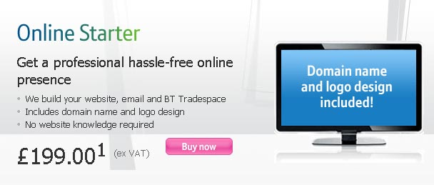
For the first time BT Business has brought together all of the essential ingredients for creating an online presence into one low cost bundle. For businesses looking to combine this with their broadband commitment, the Online Starter Kit is also available at just £5 per month with BT Business Total Broadband Option 3.
The bundle includes a web site design consultation and professional web site build, logo design, advice around web site copy and keywords, web hosting, domain based webmail and a BT Tradespace profile - all designed to work together to boost a business presence on search engines such as Google.
One in five small businesses don't have their own web site, despite £78 billion - 25% of UK retail spend - in this year projected to come from online sales. According to BT Business research the vast majority that do are also not getting the most out of their websites or using them effectively to attract customers. Just one in over 3,000 web sites use keywords in the content they post on their sites, despite the use of keywords increasing the chances of search engines picking up web pages. 42% have websites with bad pages containing broken or invalid links**.
"Every business needs an effective online presence that works well with search engines, but this can sometimes be a daunting step for start-ups," said Jerry Thompson, Director Business Products and Online. "By bringing everything together in one low-cost bundle BT is helping small businesses take the vital steps to getting online hassle-free. 20% of small businesses now also use social networking sites to win new business, so getting your company web site to work more effectively with social business networks such as BT Tradespace is becoming more and more important."
BT Tradespace is a dynamic online community for sales and marketing and offers a comprehensive directory of small business products and services. It allows members to use the latest social media tools - podcasts, videos and blogs - to promote themselves, engage with customers, partners and suppliers and sell goods to consumers over a secure and safe trading platform.
-ends-
Notes to editors:
* Based on 12mths contract. The Online Starter bundle costs £199 ex VAT. This comprises monthly costs of £5 per month ex VAT for a web hosting service plus a one-off cost of £139.
** Conclusion of an investigation of 70,000 websites released by BT Business in March 09.
About BTTradespace.com
BTTradespace.com is a 350,000-member online community, which enables businesses to sell products and services and connect effectively with other people - in order to build business and customer relationships. BT Tradespace provides social networking for businesses and free website set-up.
About BT
BT is one of the world's leading providers of communications solutions and services operating in 170 countries. Its principal activities include the provision of networked IT services globally; local, national and international telecommunications services to our customers for use at home, at work and on the move; broadband and internet products and services and converged fixed/mobile products and services. BT consists principally of four lines of business: BT Global Services, Openreach, BT Retail and BT Wholesale.
British Telecommunications plc (BT) is a wholly-owned subsidiary of BT Group plc and encompasses virtually all businesses and assets of the BT Group. BT Group plc is listed on stock exchanges in London and New York.
PR Contact:
Dan Thomas
Senior press officer
BT Group Newsroom
BT Centre
81 Newgate Street
London
EC1A 7AJ
020 7356 5369
www.bt.com/newscentre

