BT Offers Free 20Mb/s Broadband Boost


Released on: June 12, 2009, 5:55 am
Author: BT Business
Industry: Internet & Online
BT has announced that millions of homes and businesses are set to enjoy a free broadband boost as BT will more than double the headline speeds for its residential and business customers.
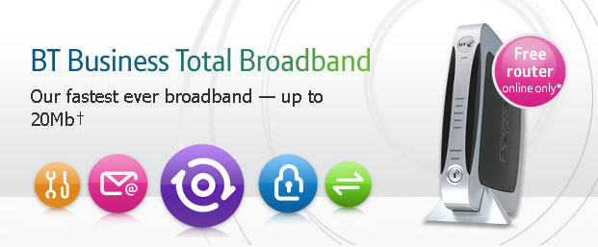
Given BT is the UK's largest retailer of broadband with 4.8 million customers, the move, which comes in advance of Lord Carter's Digital Britain Report, will lead to an increase in average broadband speeds.
Over 60,000 consumers already have the faster speeds through a BT trial and the upgrade to ADSL 2+ technology will be available to other homes in the summer. BT Retail broadband customers already enjoy speeds of up to 8Mb/s. The plans will see consumers and business in enabled areas receive faster speeds of up to 20Mb/s as part of their broadband service at no extra cost.
Based on BT's 21CN platform, the faster speeds will initially be available from 549 telephone exchanges, serving more than 40% of UK homes and businesses. BT plans to extend that coverage to 55% by March 2010 subject to customer demand.
As well as boosting download speeds, upload speeds will increase to up to 1Mb/s. The faster service will enable customers to surf, upload or download data in a fraction of the time, even when several users are on the same connection. This means less waiting around for complex web pages to download and graphics to upload. It is also good news for BT Business Broadband customers looking to use rich media or boost their websites.
BT research has shown that one of the major causes of slower broadband speeds lies in customers' home wiring. To address this, BT is also set to offer the BT Broadband Accelerator (BT I-Plate) that eliminates electrical interference from telephone-extension wiring, and can improve broadband speeds and reliability. BT will be giving away the devices free to consumers (subject to £2.50 P&P) and businesses that are likely to benefit. Crucially, this will mean more customers with marginal broadband speeds will exceed the 2Mb/s threshold required to benefit from the full range of new internet services, something Lord Carter's report is set to address.
Gavin Patterson, chief executive officer, BT Retail said "Unlike other providers, BT is upgrading customers to 20Mb/s for free. High-speed broadband provides a faster and more reliable service that will transform the way we live, work, learn and play. We believe the true value of broadband is in helping customers enjoy the exciting new services that it makes possible. In line with the Government's Digital Britain review, we will be making higher speeds more widely available."
In a separate move, BT Retail will begin the first trials of up to 40Mb/s super-fast fibre-based broadband in Whitchurch, South Wales and Muswell Hill, London this summer. Openreach is already delivering speeds of up to 100Mb/s to customers in the Ebbsfleet Valley in Kent, using fibre-to-the-premise (FTTP) technology.
Notes to editors:
New or re-contracting BT Business Broadband and BT Total Broadband customers in an enabled exchange area will automatically be eligible for the ADSL2+ service at no additional cost. The new ADSL2+ service will be available to business users from the initial launch, and non-business customers from early summer. The BT Business Total Broadband tariff remains the same and includes BT Openzone Wi-Fi minutes.
About BT Business
BT Business understands the challenges that businesses face in the current climate, and supports cost control, improved productivity and winning business through product collections including business broadband & internet, domains & web hosting, data & voice networks, IT solutions and mobile services.
For further media enquiries please contact the BT Group Newsroom - 020 7356 5369
PR contact:
Kina Kara
BT Group Newsroom
BT Centre
81 Newgate Street
London
EC1A 7AJ
020 7356 5369
www.bt.com/newscentre

