Bespoke Breasts


Released on: June 9, 2009, 8:02 am
Author: The Hospital Group
Industry: Healthcare
With the ever rising demand for breast enhancement, The Hospital Group, one of the country’s leading providers of cosmetic surgery, has launched the revolutionary new Natrelle™ breast implants from Allergan.
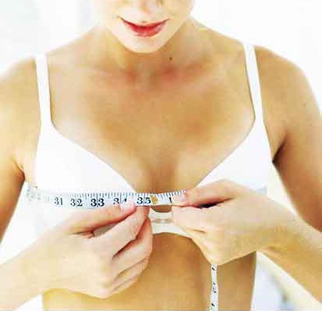
With a range of over 500 implants, the patient has a choice of four projections and gel types as well as a number of textured and smooth surfaces, allowing a more natural and individual breast enhancement.
Surgery isn’t something to be taken lightly, and to ensure the patient is in control every step of the way, The Hospital Group’s surgeons utilise the latest Biodynamics® Breast Analysis System which will measure the breast accurately and assist in selecting the perfect Natrelle™ implant based on the individual’s requirements.
A total of up to 36 detailed measurements may be taken during the consultation, followed by a discussion of the patient’s preferences and expectations in terms of cleavage, shape, size and feel.
The amazing new software also offers a visualisation system, enabling the patient to see and feel the effect of the enhancement before undergoing surgery by wearing a specially designed vest with externally worn simulated breast prosthesis.
David Ross, chief executive of The Hospital Group, said: “Our main concern when performing any form of surgical procedure is that the patient is 100 per cent happy with the end result.
“This fabulous new technology allows patients to actually see the difference our bespoke implants will have on both posture and appearance before undergoing any form of treatment. This in turn ensures patients will be completely satisfied with the proposed enhancement”.
Since The Hospital Group was established in 1992, it has grown from a small pharmaceutical company to one of the UK’s foremost cosmetic surgery providers. The Group is committed to providing the very highest standards and all procedures are performed by an expert medical team in state-of-the-art facilities that are second to none.
Contact Details: For further information on The Hospital Group’s range of cosmetic surgery procedures please visit www.thehospitalgroup.org or call 0845 762 6727.

