Brian Gay Romps to Another Wire-to-Wire PGA Tour Win Wearing Kaenon® Polarized

Earns spot in this week’s US Open with second victory in last five tournaments
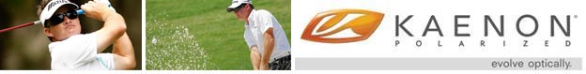
Released on: June 17, 2009, 6:05 am
Author: Kaenon Polarized
Industry: Apparel & Fashion, Sports
Newport Beach, CA (June 15, 2009) – Claiming his second victory in his last five events on the PGA Tour and the third win of his career - all while wearing Kaenon Polarized - Brian Gay birdied three of the first six holes on Sunday to take all the suspense out of the final round of the St. Jude Classic presented by FedEx as he ran away from the field to take the $1M first prize. Showing an incredible level of calm composure, patience, and focused determination from behind his Kaenon Polarized sunglasses, Gay’s flawless putting set up by solid tee-green play at TPC Southwind in Memphis, TN., helped him finish 18-under to win by 5 strokes, moving him into fourth in the overall FedExCup point standings while also earning him a spot in this week’s US OPEN at Bethpage Black. Kaenon’s Robert Allenby and John Daly were also featured prominently as the tournament unfolded.
Reminiscent of his record-setting 10-stroke victory in April at the Verizon Open in Hilton Head,SC., Gay once again demonstrated an unparalleled ability to assess the terrain, read grain and “see the line” as he wore Kaenon Polarized sunglasses for every shot he played in the tournament. Gay wore the Kaenon Polarized JETTY with Gray 12 lenses, relying on the company’s patented SR-91®lens material, purpose-built lens tints, and re-engineered polarizing elements for superior visual clarity, depth perception and color contrast, with results that clearly speak louder than words.
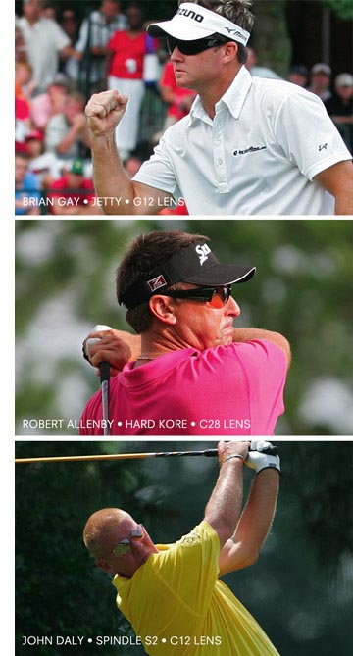
Kaenon Polarized golfers Robert Allenby and John Daly also added to the Kaenon-laden exposure over the weekend, making a total of three different players, wearing three different Kaenon Polarized styles with three different lens tints on display at the St. Jude Classic. Gay in Jetty G12, was pushed in the final group both Saturday and Sunday by Robert Allenby playing in Hard Kore with Copper 28 lenses, ultimately finishing fourth, and John Daly played in the company’s lightweight metal, Spindle S2 in Copper 12. Allenby was in contention until Gay pulled away in the final round, while Daly returned to the PGA Tour, making a big splash with his trimmed-down physique, a new clothing line and quality play. Daly will continue to split his time on the US and European PGA Tour this year.
These three players, all wearing different Kaenon Polarized styles and tints, prove how individual style, performance and comfort levels can be found in the Kaenon Polarized collection – as the company caters to individual needs through innovative frame design and superior lens technology found in their SR-91 polarized lens.
To honor Brian Gay’s St. Jude Classic victory – along with Robert Allenby, who, like Gay is also a father of two - Kaenon Polarized will be running a unique Father’s Day promotion heading into this week’s US Open – that will hinge around Gay or Allenby winning the US Open on Father’s Day. Only available to members of the Kaenon Polarized online community. To learn more about the Kaenon Polarized Father’s Day promotion you must sign up at http://kaenon.com/mailinglist.
Fused with inventive and soulful designs, the Kaenon Polarized Performance Lifestyle collection of men’s sunglasses, women’s sunglasses and sport sunglasses continues to achieve an unprecedented balance of performance and style – as they continue to win on every level of professional golf.
Kaenon Polarized. Evolve Optically®.
# # #
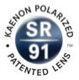
Founded by elite-level sailor, Olympic sailing coach, and Southern California native, Steve Rosenberg and his brother Darren, Kaenon Polarized represents the culmination of Rosenberg’s 20+years of experience in the sports optics world as a sponsored athlete, sports marketer, and executive. Since its launch in 2001 with its patented SR-91 lens, Light Transmission Level Technology, and award winning KORE product, Kaenon Polarized has continued Rosenberg’s mission to provide the elite athletes and active lifestyle enthusiasts with the clarity of polarized optics and high-performance frames with superior fit and luxurious style. Today, Kaenon Polarized is the performance lifestyle choice of professionals in both land and water sports such as golf, baseball, snow, surf, kitesurfing, windsurfing, fishing, sailing, and automotive racing, as well as entertainers in film and music.
Media Contact: Chris Denny / 435.655.1609 / chris@dennyink.com

