Celebrity Radio Networks
“Radio You Control”
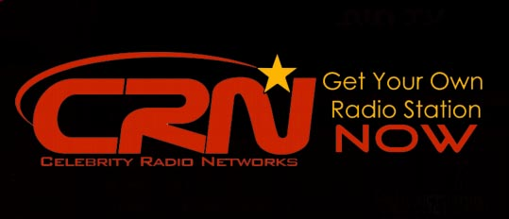
Released on: June 16, 2009, 4:44 am
Author: Celebrity Radio Networks
Industry: Media
New Business Launch
Celebrity Radio Networks: Artist/Brand Controlled Radio – June 16, 2009
New York based Emerging Media Concepts is launching Celebrity Radio Networks a (24) twenty-four hour radio stream and website targeting the artist and entertainment industry. The website and stations will serve as the premiere artist/brand radio industry facilitator on the web for purposes of programming artist/brand content, ideas and promotion.
The personal radio station broadcast will highlight musicians, entertainers, and athlete’s personal radio content on worldwide internet radio stations; a one stopshopping portal for celebrity radio controlled information and marketing. Included in this portal are other great tools aimed at promoting the artist/celebrity to consumers while being controlled by the actual artist/celebrity. Interactive and self empowering for the entertainer.
Celebrity Radio Networks is targeted to consumers and fans of artist and entertainers. Therefore it will be marketed to the general public. It is intended to serve as the personal radio home of entertainers for daily information, music, and marketing. Visit http://www.celebrityradionetworks.com for more info.
Contact: Media Relations Manager
mrm@celebrityradionetworks.com
676A Ninth Avenue
Suite 322
New York, NY 10002
(646) 205-1614

