Drug Rehabilitation Video Pays Tribute to Narconon Graduates
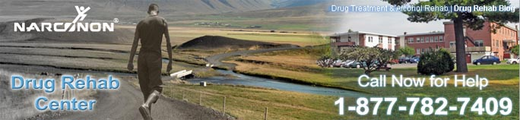

Released on: June 11, 2009, 5:49 am
Author: Narconon Drug Rehab
Industry: Healthcare
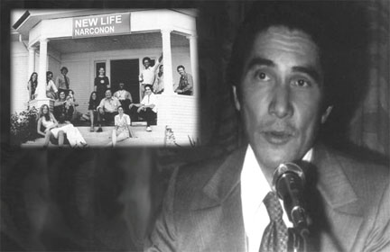
Trois-Rivieres, Quebec – The Narconon Trois-Rivieres drug rehab program recently put together a new drug rehab video paying tribute to some Narconon drug rehab graduates, and the Narconon program founder, William Benitez. In this video there is a small clip of the amazing drug education lecture given by Benitez over 40 years ago. He talks about how drugs are the easiest way to hurt a person. He says: “The quickest way to hurt a person, or a nation, or a group, the quickest way to hurt a person’s goals, his aims, his ability, his life, is by introducing that person to narcotics.”
This statement made by Mr. Benitez is the absolute truth. Everyday, there are more and more people being introduced to narcotics. When this happens, these people start down a path that could potentially take everything. William Benitez was aware of this 40 years ago, when he overcame his own 19 year long addiction to heroin, and other drugs. He started the first Narconon therapy group that saved his life, and the lives of twelve other inmates. This video production gives a glimpse of where some of the graduates of the Narconon drug rehab program were in the midst of their addiction, and then the video shows where these graduate are, after completing a drug rehab program.
The Narconon drug rehab program has produced well over 25,000 graduates worldwide. With a network of 150 centers in over 40 different countries, the Narconon drug rehab programs purpose is to help save as many lives as possible. If you or someone you know is battling a drug or alcohol addiction, call our toll free line at, 1-877-782-7409, or visit,http://narcononrehab.com/
© 2009 Narconon Trois-Rivières. All Rights Reserved.
NARCONON is a trademark and service mark owned by Association for Better Living and Education and is used with its permission.

