Eco-Friendly Printing, The Answer To Reducing Our Carbon Footprint On This Planet
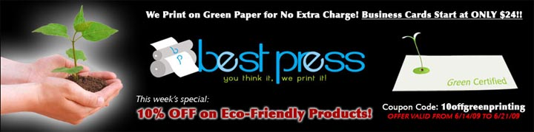

Released on: June 15, 2009, 4:34 am
Author: William Alexander
Industry: Small Business
La Jolla, CA -- Have you noticed how much printing there is all around you? Everything is printed, from the letters on the keyboard of your computer, the news papers and magazines that you read on a daily basis, business cards, flyers, brochures, money and checks, your clothing and its tags, posters and advertisements on the street a all the way to that lovely pattern on your kitchen floor. The list is endless! Eco-Friendly printing can make all of those products greener.
Eco-Friendly printing is achieved by using Green Certified substrates (such as paper and other materials) which either comes from tree farms (trees grown for the sole purpose of producing paper) or has a high content of recycled material. In addition, one of the most important components is soy based inks, which are 100% organic. With our modern technology, soy based inks can achieve the same color intensity, durability and brightness than conventional VOC releasing (volatile organic compound) inks which are solvent or oil based. Or even worse, Chinese printing, their inks have a high content of lead. Many U.S. magazine companies are now printing in China to save money, there is nothing wrong with saving a few bucks, right? Well, the problem is that we are killing the planet by using conventional printing and also our selves. Think about it, when you hold a magazine in your hands and you flip through it, how many times do you take your index finger to your mouth to get some moisture, so that the pages stick better and you can keep flipping through the magazine? Every time you do so, you are eating lead! On top of that, the printing industry employs more people in the U.S. than the car manufacturing industry, and now it is being outsourced to China.
While it is more expensive for printing companies to produce Eco-Fiendly products, the benefits of doing so are significant, and ultimately responsibility is not just good for our planet, but good for us as well. Today in the U.S., there are a few companies out there that will absorb this overhead cost and print "Green" at no extra cost to the consumer. A great example of such a company is Best Press, based out of La Jolla, CA., http://www.BestPressOnline.us. Best Press, not only does it create American jobs, but it gives businesses, corporations and consumers the option to print Green at no extra cost. Their pricing is extremely reasonable, and in most cases below industry average. So if you are in need of some business cards, flyers or any other printing for your self or your business or corporation, look no further than an environmentally conscious company, your children will be glad you did so!
Contact Details: 5328 La Jolla Hermosa Ave, La Jolla, CA 92037
Website: http://www.BestPressOnline.us
Contact: info@BestPress.us
Phone: 858-432-0258
Fax: 858-946-0494

