Eupelix LLC Develops Low Energy, Low Emission Process Of Refining Petroleum

Released on: June 4, 2009, 10:56 am
Author: Dr. Dmitri V Novikov
Industry: Energy
CHAMPAIGN, Ill. – Scientists of Eupelix, LLC have developed an ecologically clean, energy efficient method modifying properties of crude petroleum, including braking down long molecules (cracking) into smaller molecules, at room temperature.
First demonstration experiments were carried out recently by Eupelix staff with the assistance of researchers from the University of Illinois College of Engineering, the Illinois Sustainable Technology Center and the Illinois State Geological Survey.
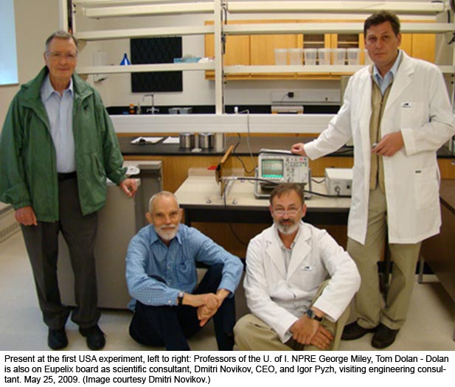
Eupelix personnel used high frequency, solid-state pulse generators in proprietary circuits and reactors to produce fast electromagnetic fields which affected the physical and chemical properties of crude oils in large volumes. The process decreased the content of heavy oil fractions, breaking them into more valuable, lighter fractions. There also are decreases in the viscosity and the content of toxic sulfur compounds.
For more than 70 years, traditional thermal cracking processes have been carried out by oil refineries at extremely high temperatures. Temperatures exceeding 500 °C have been used to break heavy oil fractions into lighter fractions to produce gasoline and diesel fuels.
“Using these high temperatures involves the extensive power consumption contributing to the cost of fuels and negative environmental impact,” said Eupelix CEO Dmitri Novikov.
Now important steps in upgrading oils can be accomplished without the use of heat, minimizing energy consumption and the impact on the environment, Novikov said.
Petroleum desulfurization is also an important issue for the oil industry trying to reduce the content of sulfur in the end products. This decreases the environmental toxicity of burned fuels. The new process facilitates desulfurization.
The method uses modern pulse equipment, which has been utilized in applications related to radar modulators, particle accelerators and lasers.
“About a decade ago, the project was in the nascent stage because the pulse equipment was not nearly as efficient as it has become in recent years. Hardly anyone tried applying it for processing of petroleum. ” said Igor Pyzh, Eupelix visiting engineering consultant.
Pyzh came from the Ukraine to assist with test experiments for prospective industrial partners and collaborators in the United States.
Using available powerful pulse equipment, hundreds of thousands of barrels of oil per day can be processed satisfying commercial-scale refining. Pyzh says, it is just a matter ofadjusting the equipment to the kinds of processed oils. This can be done in the new Euplex lab in Illinois.
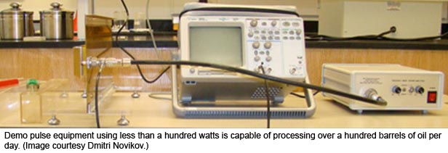
“There are also other interesting, ecologically clean applications that we are exploring together with our collaborators,” Novikov said.
The major efforts of the company are focused on applying this process to large scale petroleumrefining for industrial partners in Illinois, the State of Eupelix registration, and for partners in the Ukraine, the home country of the invention.
CONTACT: Dr. Dmitri V. Novikov
dmitri.novikov@eupelix.com
217-351-3542 Eupelix, L.L.C.

