First Nations Launches Native Asset-Building Partnership Project
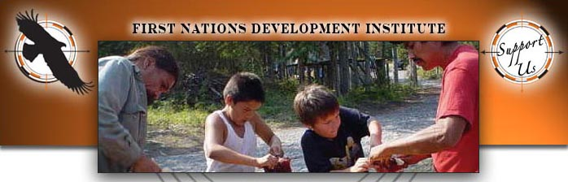

Released on: June 10, 2009, 4:13 am
Author: First Nations Development Institute
Industry: Non Profit
Longmont, Colorado- First Nations Development Institute (First Nations) released the names of the advisory committee members for its new Native Asset-Building Partnership. Members include Anita Fineday, Chief Judge of the White Earth Tribal Nation; Tadd Johnson, Special Counsel for Government Affairs for the Mille Lacs Band of Ojibwe; Susan White, Director of the Oneida Trust Department; former Senior Vice President and board member of First Nations, Sherry Salway Black; Elsie Meeks, Director of the USDA Rural Development Office; attorney Margaret Schaff, partner at Schaff & Clark-Deschene; Tracy Fischer, Interim President of the First Nations Oweesta Cooperation; and Michael E. Roberts, President of First Nations Development Institute.
The goal of the Native Asset-Building Partnership Project is to strengthen tribal and Native institutions in Minnesota, Wisconsin and North Dakota through tribal nation-to-nation peer learning and model development that will lead to improved control and management of assets for the benefit of Native communities and individuals. Advisory committee member Susan White said, "Peer mentoring will provide ideas and processes on how Indians as the true stakeholders can gain greater control over their own assets. Applying mentoring objectives will elevate a tribe's ability to be more self-determined and therefore gain greater control over their own assets."
First Nations' goal is to partner tribes around specified assets and allow them to share best practices for asset stewardship and management. "Through this project we will be able to continue to ask questions from our brothers and sisters at other tribal nations and create long-term enduring benefit to Indian Country," notes advisory committee member Anita Fineday who is Chief Judge of the White Earth Tribal Nation located in White Earth, Minnesota.
Sherry Salway Black said "assets are incredibly important for individuals, families, communities, and nations - including tribal nations. The ownership, control, management and development of current assets and creation and acquisition of new assets taken together are wealth and assure a better future."
The Native Asset-Building Project advisory committee is composed of national and regional leaders familiar with asset-building in Native American communities. "First Nations is grateful to have the participation of such well respected national and regional leaders in Indian Country," said Michael E. Roberts. The project advisory committee will assist in engaging tribes and Native organizations in the targeted states to determine asset-building needs and regionally-relevant models and assist in the planning and hosting of an asset-building conference that will take place in Minneapolis, Minnesota this fall.
The Native American Asset Building Project is a two-year project funded by the Otto Bremer Foundation, based in Saint Paul, Minnesota. For more information about First Nations' Native Asset Building Project, contact Raymond Foxworth, Research Officer for First Nations at 303-774-7836 or rfoxworth@firstnations.org.
About First Nations Development Institute
Founded in 1980, First Nations Development Institute is a national Native American-led nonprofit organization. Through a three-pronged strategy of Educating Grassroots Practitioners, Advocating for Systemic Change, and Capitalizing Indian Communities, First Nations Development Institute is working to restore Native control and culturally-compatible stewardship of the assets they own - be they land, human potential, cultural heritage, or natural resources - and to establish new assets for ensuring the long-term vitality of Native communities. To learn more about First Nations, visit:www.firstnations.org.
Contact Details: Raymond Foxworth
703 3rd Ave, Suite B
Longmont, CO 80501
rfoxworth@firstnations.org
www.firstnations.org
303-774-7836 x 20
303-774-7841 fax

