Foreign Juggernauts Causing More Accidents On British Roads


Released on: June 4, 2009, 11:03 am
Author: Staveley Head
Industry: Financial
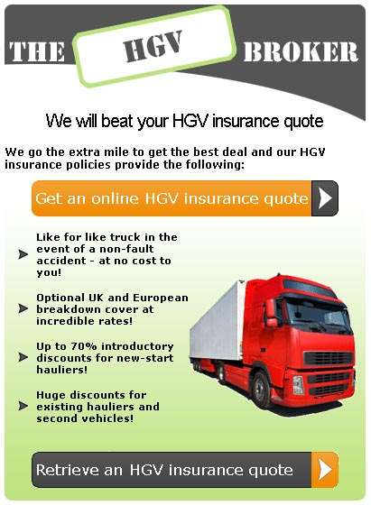
New figures compiled by traffic specialists Accident Exchange show that the number of accidents caused on British roads by foreign juggernauts has increased in the twelve months to the end of February 2009 by 10%. The total number of accidents involving foreign lorries in the UK is about 9,000, but the proportions vary significantly around the country.
Nearly 50% of the total number of accidents occurring on the M25 are caused by foreign left-hand drive trucks, which is 25% of all the accidents in Britain where overseas registered trucks are at fault.
According to the last statistics released by the Department of Transport the worst offenders are Polish drivers, closely followed by those from the Czech Republic, Lithuania and Hungary.
Many of the accidents are caused by what is known as 'sideswiping' which happens when a juggernaut pulls out to overtake, and due to a blindspot is unaware of an overtaking vehicle.
A spokesman for Staveley Head, one of the country's leading HGV insurance providers, said "The Government has been aware of this problem with foreign lorries for quite some time, and to some extent has taken steps to resolve it by providing magnifying door mirrors, also called Fresnal lenses, to some 200,000 foreign lorry drivers entering the country in the last year. It is disappointing that their efforts have not only failed to reduce the number of accidents but have also failed to prevent a substantial increase."
The Staveley Head spokesman went on to say "10% of sideswipes result in the smaller vehicle being an insurance total loss, or write-off. I believe the average claim cost being quoted is in the order of £1,872, but the human tragedy cannot be measured. Many injured parties get nothing at all as the foreign drivers claim not to speak English, give false details, drive away from the accident without stopping or cannot be located by insurance investigators in their home country. Some simply don't have any insurance cover at all."
If you want further information about this subject, or want to know more about insurance for trucks, Staveley Head will be pleased to assist.
Staveley Head is one of the UK's leading lorry insurance providers and will give you all the advice and assistance you need, including a very competitive truck insurance quote, if you log onto their website at www.staveleyhead.co.uk
For more information on any aspect of transport insurance contact Staveley Head on 0845 017 9991 or email quotes@staveleyhead.co.uk
Contact Details: Staveley Head, Flint , United Kingdon, 0845 017 9991, quotes@staveleyhead.co.uk

