Heartbreaking Drug Addiction Story Shown on New Rehab Blog
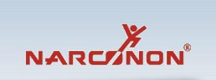

Released on: June 24, 2009, 8:37 am
Author: Narconon
Industry: Healthcare
Trois-Rivieres, Quebec – The Narconon drug rehab blog has recently been publishing a heartbreaking; yet, inspiring true story of a woman’s drug addiction. Sabrina was a drug addict and runaway from Montreal, Canada, who saw her own demons destroy her life and the life of her family. Talking about her family at the time, Sabrina said in the interview: “I tried to make sure they were as far away from me as possible. I didn’t want to think about them – I didn’t want to have a family.” Recent postings on the new Narconon drug rehab blog show a short 60 second trailer of the soon to be released full-length interview.
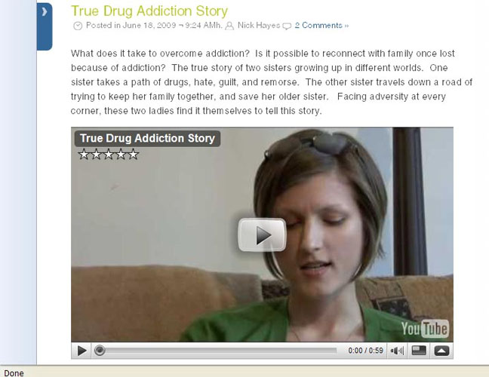
With blogging being one of the most effective ways to get information out there, the Narconon drug rehab program wanted the opportunity to share some true stories, and also post some useful information to help those struggling with addiction. This informative new blog features categories such as, Drug and Alcohol Fact Sheets, thesearticles will give readers the hard facts on drugs, not sugar coating the devastating impact these drugs have. There are two similar categories, Overcoming Addiction, and Drug Addiction Stories. Both of these categories feature true and fictional stories of people battling drug addiction. It shows in great detail the pain and suffering caused by drugs and alcohol, it also tells of the inspirational moments of those people who overcame their own addictions.
If a reader is interested in keeping up to date on the recent activities of the Narconon Trois-Rivieres drug rehab center, there is a category on the blog, Drug Prevention News, which talks about all the recent events and activities taking place. Drug addiction is a very powerful demon to fight, and millions of people are battling it everyday. The ones that have beaten their addictions need to tell their story. Those still battling need to see that achieving life long sobriety is possible. This is one of the main purposes of this new drug rehab blog. For more information about drug addiction, or if you or someone you know is battling drug addiction. Call the Narconon drug rehab toll free line at, 1-877-782-7409. You can also visit the Narconon drug rehab programs website at,http://narconon.ca/
© 2009 Narconon Trois-Rivières. All Rights Reserved.
NARCONON is a trademark and service mark owned by Association for Better Living and Education and is used with its permission.

