Lovetropolis.com Offers Innovative Lifetime Membership Pricing Strategy to Online Daters
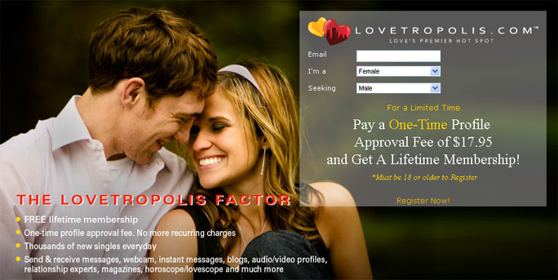

Released on: June 23, 2009, 1:51 am
Author: The Lombard Company, Inc.
Industry: Internet & Online
MARYLAND, June 22 -- Lovetropolis.com, the groundbreaking internet dating site, is once again offering innovation to online singles looking to meet and find love with the launch of Lifetime Membership pricing. Starting today, millions of singles interested in dating online won't have to stretch their budgets to do so. Singles joining Lovetropolis.com will pay only a one-time profile approval fee. Besides this nominal amount, which is less than the cost of going to the movies, members will pay absolutely nothing for the lifetime membership to Lovetropolis.com. "With the new Lifetime Membership offer, we are letting people connect with one another much more affordably," said Michael Lombard, CEO of Lovetropolis.com. "With our Lifetime Membership pricing, we intend to change the scene of internet dating. We have eliminated the monthly recurring fees by giving members who take advantage of the offer lifetime access to the entire Lovetropolis.com network."
With Lovetropolis.com's new pricing strategy, millions more singles will actually be able to afford to find love online and enjoy the inventive blend of technology that can only be found on Lovetropolis.com. After members have paid the one-time profile approval fee of less than twenty dollars, they will pay nothing again…ever.
"Imagine what Lifetime Membership pricing will do for average singles who are trying to balance their budgets and enjoy a productive social life," said Michael Lombard. "They are thinking that the prices charged by sites like eHarmony and Match.com are cost-prohibitive; and suddenly they receive an affordable offer from Lovetropolis.com that guarantees them a lifetime of cutting edge dating services for less than the cost of one date. It will make online dating accessible to so many more singles and will revolutionize the industry."
Current members simply upgrade to the Lifetime Membership from their Lovetropolis.com online account at http://www.lovetropolis.com/. And singles new to Lovetropolis.com can subscribe as lifetime members by visiting the site's home page. According to Shandale Tucker, another operations executive at Lovetropolis.com, the Lifetime Membership pricing limited time offer is available worldwide beginning today.
For more information, visit http://www.lovetropolis.com/, email Shandale Tucker, Executive Vice President of Operations, at s.tucker@lovetropolis.com, or call The Lombard Company, Inc. at 800-760-6011.
About Lovetropolis.com
Lovetropolis.com, love's premier hot spot, is a new, upscale dating agency designed to make certain that members enjoy a VIP experience in a dynamic, well-appointed environment. Lovetropolis.com caters to singles who are savvy and embrace the idea that everyone deserves to find love.
Lovetropolis.com is one of the major online dating sites, according to Online Dating Magazine and is “The Next Great Dating Service ” according to ALoveLinksPlus.Lovetropolis.com modernizes the online dating experience by providing a fusion of exceptional features that assist members in making a lasting match. Lovetropolis.com already has members from 23 countries worldwide.
The energy and atmosphere of Lovetropolis.com is vibrant and unrivaled, setting an ideal mood for matchmaking and social connectivity. Singles subscribing to Lovetropolis.comwill enjoy their leisure social time, affordably fulfill their recreational and romantic needs, and appreciate the indulgent customer service afforded them each time they log in. See why we are the premier online dating site at http://www.lovetropolis.com/.

